Hosting Proforma
Department of Education

Name of Host
Organisation

1. Interchange Manager’s details
Dale Heaney
Name

Organisation/
Tackling Educational Disadvantage Team
Department
Rathgael House
Balloo Road
Bangor
BT19 7PR
Address

02891 279402

Telephone Fax number
N/A
Number
dale.heaney@education-ni.gov.uk

E-mail

Type of Opportunity
Secondment – RAISE Programme - Deputy Evaluation Manager

2. Details of hosting opportunity

Description of opportunity

- The Department of Education is embarking on a transformative and innovative new programme of work. The RAISE programme is a whole community and place-based approach in eighteen areas across Northern Ireland to support the Department’s vision that “every child is happy, learning and succeeding”. It helps to deliver on the mission, set by the report ‘A Fair Start’, to ensure all children and young people regardless of background are given the best start in life.

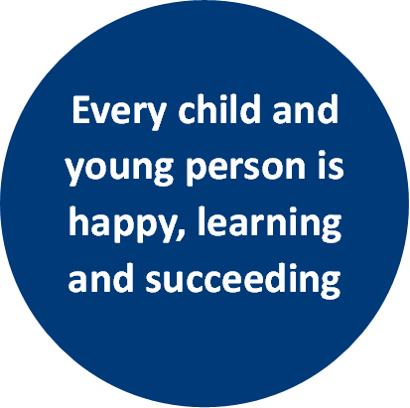
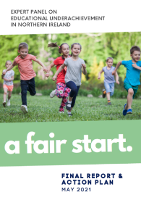
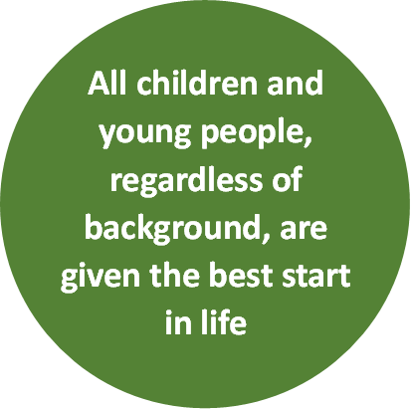
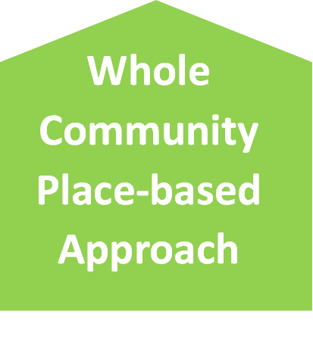
RAISE
(Raise achievement to reduce educational disadvantage)

- A Fair Start’ was published in 2021 by an Expert Panel examining the link between educational underachievement and socio-economic background. Its goals included drawing up an Action Plan for change to “ensure all children and young people, regardless of background are given the best start in life”. The Panel advocated that addressing educational underachievement “means placing equality of opportunity at the core of everything we do”.

- A substantial investment by Shared Island of c£20m over 2 years (with the possibility of 2 further years funding) will include support to codesign strategic plans in each locality, with delivery being rolled out via community-informed projects as well as cross-cutting initiatives which can span, connect and share learning across localities, regionally and on an all-island basis. This requires partnerships and on-the-ground working relationships with organisations and communities across these localities. This requires engagement and the establishment of partnerships with children/youth organisations, families, communities and schools across localities through having a visible presence.

- This approach matters because a child spends only around 14% of their lives until adulthood in a classroom and compulsory education. Schools nevertheless play a pivotal role in the lives of our children and young people, but they require support to meet the holistic needs of their pupils, all of which impact on their learning but some of which are outside the scope of a school’s remit.

- A whole community approach to education extends beyond the school gate and means children and young people are supported in all contexts in which their lives are lived. It recognises a learning and support continuum for children and families/carers, from pre-birth through to young adulthood, and multiple pathways that can be available.
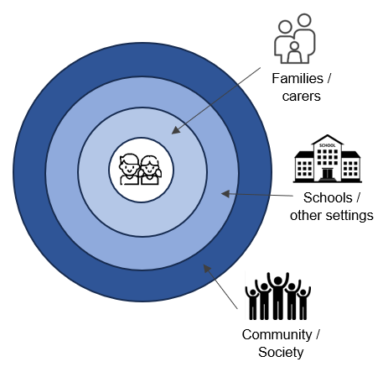
Children and young people are at the centre of a place-based and whole community approach to education.

This means local partnerships of schools, communities and families/carers helping children and young people to be happy, learning and succeeding.

This will promote inclusion and equality of opportunity, enabling more to fully develop their potential, increase their attainment and improve life chances.

- The Programme design applies a child centred, community informed and inclusion focused lens to the design and delivery of educational initiatives which are area based and in localities identified based on need.

- This involves a bespoke local Strategic Plan for each place, codesigned by schools, children, families and community and others with a role to play in supporting children’s learning in the communities in these localities.

- Collaboration enabled by these plans will build on good practice, test innovative approaches and identify and enhance pathways which promote equality of opportunity for those who face barriers to their learning and are at risk of exclusion, marginalisation and under-achievement.

- The programme will run initially for 2 years (starting in 2024) and potentially extend for a further 2 years subject to evaluation. Learning from the RAISE programme will inform policy development and better ways of working together to realise the vision of every child is happy, learning and succeeding. An Advisory / Expert Panel comprising experts and practitioners will be established to support this goal.

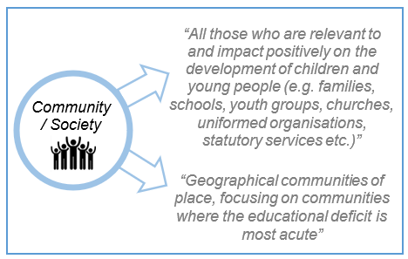
“There should be a focus on communities and families in the most disadvantaged areas. Place-based partnerships should be developed as part of a proposed new ‘Reducing Educational Disadvantage’ (RED) programme”

- The Department of Education as the responsible Department is seeking to establish a Delivery Team with a range of different skills and expertise. This is an exciting opportunity to be involved from the inception of a transformational programme in education to help shape, design and implement which will impact on the lives of children and young people. This team requires a mix of experience including programme management, locality engagement & relationship building, communications research & evaluation and administrative roles.

- A key part of the RAISE Delivery Team will be its evaluation and reporting upon programme delivery. This post holder will support the Programme Governance and Evaluation lead who will plan, design and deliver the RAISE Programme and Governance Framework including the Risk Register, including developing evidence to inform the development and delivery of interventions. This will include analysing the overall sense and value of the delivery being progressed including the underlying theory of change.

Main objectives of the opportunity

The RAISE Programme - Deputy Evaluation Manager post will report to the G7 RAISE Programme Governance and Evaluation lead.

The post is likely to be based in Rathgael House, Bangor but travel to the 15 RAISE areas will form an important aspect of the work.

The main responsibilities of each RAISE Programme Evaluation post will be:
- Develop a detailed understanding of the interventions across all localities, through working with delivery organisations to develop the overall sense and value of the interventions. This will include collecting and collating project data (a bespoke IT monitoring system is being developed for the programme) and through semi-structured interviews to build a qualitative evidence base.
- Using and promoting the reporting tool(s) to ensure programme is monitored effectively.
- Report periodically on progress at both a summary and detailed level per programme and locality.
- Identify evidence of effective practice to be promoted via shared learning across localities and recommended for DE Mainstreaming/Budget as well as areas of ineffective practice which should cease.
- Preparing & presenting analysis of work completed as appropriate to the Shared Learning & Research Board, Programme Board, sub-groups and other appropriate fora.
- Supporting discussion on key themes such as “pupil attendance at school” and develop appropriate analysis etc.
- Analysing and presenting data that helps to inform strategic delivery, communications and engagement.
- Work with Communications lead to promote the programme and its achievements.
- Work with BLAST and T-REX project leads to identify and promote effective practice.
- Provide annual reports on achievements for Minister and senior staff.
- Take on any other additional responsibilities required by the Programme Manager / Programme Governance and Evaluation lead / DE.

3. Skills requirements

What qualities, skills and experience are required from the individual

Essential Skills & Experience

- A minimum qualification of undergraduate degree or higher qualification in a relevant subject which demonstrates research, analysis, monitoring & evaluation.
- At least 3 years practitioner experience of work which has research, analysis, monitoring & evaluation.
- Experience of analysing and reporting on qualitative and quantitative data.
- Demonstrate an awareness of educational underachievement.
- Excellent communication skills, both verbal and written, including judgement required to communicate complex information clearly to a range of stakeholders.
- Experience of data analysis and reporting and a local, area and strategic (NI) level.
- Experience of setting challenging (SMART) targets which can reflect the achievements of a range of different interventions, projects and policies.
- Drafting, establishing and managing a programme based-evaluation framework.
- Excellent communication skills, both verbal and written which conveys the success or otherwise of projects, programmes and policies in a variety of different ways including Outcome Based Accountability – How much did we do? How well did we do it? Is anyone better off?
- A track record of working with a range of stakeholders and representatives and using personal credibility to build relationships and add value.
- Experience of presenting results of work to a number of different audiences with differing levels of detail required.
- Ability to work with others to define data and reporting requirements, setting out clearly the data required, how it should be reported upon and how it can lead to delivering change in policy / delivery.
- Experience of writing reports and the sourcing, analysis and presentation of data and management information.
- Contribute to successful team working.
- Proficiency in MS Office suite and other more complex reporting tools such as SPSS, MS Access, PowerBI, Tableau Public or equivalent.

Desirable Skills & Experience
- Previous experience of data analysis and reporting at a strategic level with a particular emphasis on education.

4. Personnel: Please state below

Who will the individual report to?
New Role – G7 Programme Governance and Evaluation

Who will be the individual’s line manager and/or reporting officer?
New Role – G7 Programme Governance and Evaluation

5. Transfer of learning
Please give details of how the Opportunity will benefit your organisation, the individual and their organisation.

Benefits for DE
The Department of Education is embarking on a transformative and innovative new programme of work. The RAISE programme is a whole community and place-based approach in eighteen areas across Northern Ireland to support the Department’s vision that “every child is happy, learning and succeeding”. It helps to deliver on the mission, set by the report ‘A Fair Start’, to ensure all children and young people regardless of background are given the best start in life

Benefits for other departments
Increasingly, there is a need within the public sector to collaborate with colleagues in other departments, local government and external agencies, in order to maximise the resources available, deliver collective impact and to ensure that the requirements asked of the school / V&C sector are clear and consistent. Lessons learnt as part of this process will be helpful in informing what happens in other departments and to inform future policy and delivery

Benefits for the applicant
This post offers the applicant the opportunity to develop the full range of competencies at this level i.e. Setting Direction, Engaging People and Delivering Results. It offers a unique opportunity to work in a new and transformational programme with localities on the ground to effect change and see the impact of the programmes and policies and investment and influence departmental policy as a result.

6. Logistics
Please provide details of the likely start date, duration, location, form of transport required, resources (i.e.; desk, PC, etc.) and funding arrangements for the opportunity.

Start Date: November 2024

Duration: 2 years with the possibility of a further 2 years.

Location: DE is based in Rathgael House, Bangor however travel to the 15 RAISE localities will form an important part of the post holder’s role, therefore access to one’s own transport is essential.

Resources: It reporting system, people and funding

Funding: Funding for the post will be provided by DE and the salary will be within the NICS Deputy Principal range of £42,315 - £45,351.

Further information: please contact Dale Heaney at dale.heaney@education-ni.gov.uk or 02891 279402

Closing Date: Applications* (Canddate Proforma) must be submitted by 5.00pm on Friday 11 October 2024 to:

interchangesecretariat@finance-ni.gov.uk

*This opportunity is not open to NICS staff

7. Endorsement

Interchange Manager

Signed:
Dale Heaney

Date:
18 September 2024

