Hosting Proforma
Northern Ireland Fire and Rescue Service

Name of Host
Organisation

1. Interchange Manager’s details
Shirley McDonnell
Name

Organisation/
Northern Ireland Fire and Rescue Service
Department
NIFRS Headquarters
1 Seymour Street
Lisburn
BT27 4SX
Address

Telephone Fax number
028 92 664221

Number
Shirley.McDonnell@nifrs.org

E-mail

Secondment – One Year with possible extension

Type of Opportunity

2. Details of hosting opportunity

Description of opportunity

Payroll Administrator

The Northern Ireland Fire & Rescue Service (NIFRS) protects and serves the entire population of Northern Ireland, an area of over 5,500 square miles and with a population of 1.9 million, providing them with a range of fire and rescue services.

NIFRS has four staff cohorts, each of which has its own structure with regard to Terms and Conditions of Employment. The Payroll Administrator will support and assist both the Senior Payroll Administrator and the Payroll Manager to ensure the competent, effective and the timely processing of all payrolls in compliance with internal policies, legislation, best practice and both National and Local Terms and Conditions of Employment.

The payroll administrator will also contribute to systems and service improvement including IT systems functionality and development.

All duties will be carried out in a manner which enhances governance and good records management and security.

A full Job Description and Person Specification is at Annex 1.

Main objectives of the opportunity

The post holder will be work as part of a payroll team and will be involved in the delivery of payroll services.

This will include demonstrating proven payroll knowledge and organisation skills with regard to:

- The development and maintenance of an up to date working knowledge of HMRC PAYE and Payroll Processes guidance and regulations.
- Maintenance and update of all Employee’s financial records.
- Maintenance of knowledge of all Terms and Conditions of Employment, ensuring correct implementation of Pay Scales and Allowances.
- Maintenance and update of sickness absence records, in line with NIFRS Sickness Policy.
- Performing calculations for multiple pay entitlements, ensuring the accurate application of all rules, regulations and terms and conditions.
- Development and maintenance of a working knowledge of employee Pension Schemes and apply in calculating pension contributions.
- Collation and provision of payroll information to a range of various stakeholders
- Compliance with GDPR and Record Retention policies
- Ensuring that the payroll computer system is functioning correctly and engagement in all new systems’ development and changes.

Full Job Description and Person Specification attached in Appendix 1

3. Skills requirements

What qualities, skills and experience is required from the individual

Either:
- Possess 5 GCSEs at Grades A* - C / 9 - 4 (or equivalent) including English Language and Mathematics;
PLUS
- Have a minimum of one years’ experience working in a payroll function to include both:
- Processing remuneration payments and other entitlements;

- Assisting with advice on payroll issues including implementation of legislative and statutory payments.
OR
- Have a minimum of three years’ experience working in a payroll function to include both:
- Processing remuneration payments and other entitlements;

- Assisting with advice on payroll issues including implementation of legislative and statutory payments.

Demonstrate:
- An understanding and working knowledge of Microsoft Office Applications.
- Effective planning, organisation, prioritising skills and attention to detail and the ability to work individually or as a team member
- Effective communication skills (both oral and written) and the ability to provide timely and accurate information
- A strong customer service orientation
- An understanding and practical experience of applying HMRC rules, including PAYE, national insurance, statutory payments and benefits in kind.
- Possess a current driving licence or have access to a form of transport that will permit the candidate to meet the requirements of the post in full.

4. Personnel: Please state below

Who will the individual report to?
Senior Payroll Administrator

Who will be the individual’s line manager and/or reporting officer?
Senior Payroll Administrator

5. Transfer of learning
Please give details of how the Opportunity will benefit your organisation, the
individual and their organisation.

This is a fantastic opportunity for a suitably qualified and experienced individual to further their experience within NIFRS during a period of significant change and improvement.

6. Logistics
Please provide details of the likely start date, duration, location, form of transport required, resources (i.e.; desk, PC, etc.) and funding arrangements for the opportunity.

Start Date: As soon as a suitable candidate has been identified and a release date has been agreed.

Duration: Secondment for One Year with possible extension

Location: NIFRS Headquarters, 1 Seymour Street, LISBURN, BT27 4SX

Resources: This post is office based and all resources will be provided. There may be the opportunity for Hybrid Working however the post-holder will be expected to be flexible to meet the needs of the role.

Funding: NIFRS will meet the salary and associated costs for the role. The salary range is currently £29,269 to £31,364. (Under Review)

Further information: Process will consist of shortlisting during December 2024 and may be followed by interview if required, which will take place in January 2025. For further information please contact Shirley McDonnell on Tel: 028 9266 4221 or by email at: Shirley.McDonnell@nifrs.org

Closing Date: Applications must be submitted by 12 noon on Monday 16 December 2024 to:

For NI Civil Service departmental staff only: secondments@hrconnect.nigov.net

For staff from all other Partner organisations: interchangesecretariat@finance-ni.gov.uk

7. Endorsement

Interchange Manager

Signed:
Shirley McDonnell

Date:
19 November 2024

Job Description Annex 1
Reference Number: Interchange I/C 67/24 Date: November 2024
Directorate: Finance
Section: Payroll
Job Title: Payroll Administrator
Grade: Scale 6
Reports to: Senior Payroll Administrator

MAIN PURPOSE
NIFRS has four staff cohorts, each of which has its own structure with regard to Terms and Conditions of Employment. The Payroll Administrator will support and assist both the Senior Payroll Administrator and the Payroll Manager to ensure the competent, effective and the timely processing of all payrolls in compliance with internal policies, legislation, best practice and both National and Local Terms and Conditions of Employment.

To contribute as an integral member of the Finance team to the provision of a modern, professional and responsive Financial Services function that demonstrates our Organisational values in all that it does, and supports the purpose, outcomes and values of NIFRS, as depicted below:
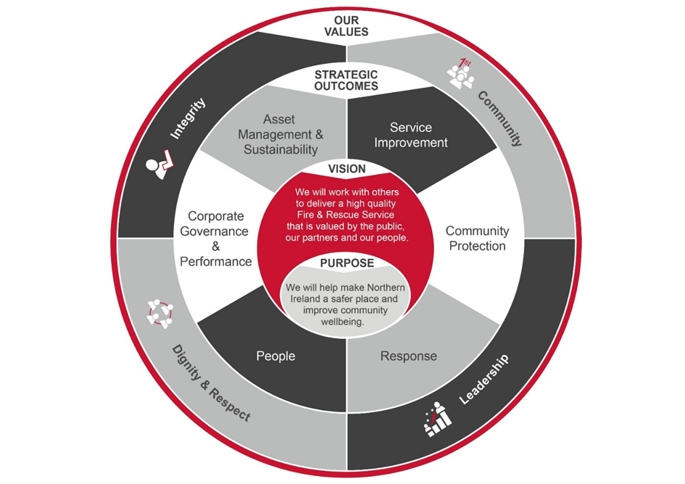

Summary of Responsibilities:

Payroll Services
- Support and Assist both the Senior Payroll Administrator and Payroll Manager to ensure the timely and accurate processing of a number of different payrolls in compliance with internal policies, legislation, best practice and both National and Local Terms and Conditions of Employment.

- Develop and maintain an up to date working knowledge of HMRC PAYE and Payroll Processes guidance and regulations.

- Responsible for the delivery of a high level of Professional Customer Service when dealing with Personal Data

- Assist in the provision of advice and guidance to Employees, HRD, Line Managers, Service Managers on matters concerning Employee’s Pay to ensure Payments are made in accordance with HR Policies and relevant Statutory and Employment Legislation

- Maintain and update all Employee’s Financial Records ensuring that all records, including New Starts, Leavers, Banking, Changes to Personal Circumstances, are correct; providing assurance that correct authorisations and accountability is in place and can be evidenced..

- Apply a robust knowledge of relevant policies to ensure accurate processing of claims, challenging claims where appropriate.

- Maintain an extensive knowledge of all Terms and Conditions of Employment applicable to NIFRS Cohorts to ensure correct interpretation of Pay Scales, Overtime and Allowances.

- Extract sickness absence information from multiple registers, updating and maintaining individual employee sick records for sick pay entitlements and in support of absence monitoring.

- Ensure all Sickness Absences are covered by the appropriate Certification, in line with the NIFRS Sickness Policy.

- Set up internal bank transfers and third party payments, verifying amounts and bank details in accordance with instructions and ensuring adherence to internal controls and authorisation limits

- Develop and maintain a good working knowledge of both the Firefighter’s Pension Schemes and NILGOSC Pension Scheme regulations and apply appropriately in calculating pension contributions.

- Collate and Provide relevant payroll information of Firefighter Pension Scheme Members to NIFRS Pension Department and HSC Pension Department as required

- Ensure that the monthly Real Time Information for upload to HMRC Government Gateway is correct and figures are reconciled to the Payroll Systems Report, ensuring any discrepancies are resolved before transmission by the Senior Payroll Administrator or Payroll Manager.

- Collate all relevant information and complete payroll journals to ensure complete and accurate recording of transactions for internal Management Reports and Statutory Returns.

- Responsible for performing complex manual calculations for multiple pay entitlements, including arrears; ensuring accurate application of legislation, pay policy and terms and conditions prior to processing payments.

- Complete electronic requisitions for external purchases, ensuring purchase orders are marked as delivered on receipt.

- Interpret weekly Establishment Instructions, implementing al resultant operational movements within NIFRS including Transfers, Temporary Promotions, Reversions and Secondments.

- Identification and application of changes to pay rates, calculating Temporary Promotion arrears and ensuring these are ceased on reversion.

- Accurate calculation of identified overpayments to support recoupment.

Governance, Data & Information Assurance

- Maintain a sound knowledge and understanding of relevant Legislation, Terms and Conditions of Employment, Policies and Processes applicable to NIFRS.

- Advise, as required, on applicable legislation, policies and processes.

- Collate and provide ad-hoc financial management information including; extraction and calculation of figures and the creation of documents using software packages such as MS Excel or Access, etc.

- Ensure all manual and electronic payroll records are stored in line with GDPR and Record Retention Policies.

- Collate and provide financial information, as requested under Freedom of Information, Assembly Questions and by Legal Representatives and Statutory Bodies, e.g. Solicitors in relation to liability claims, matrimonial proceedings, Child Support Agency, Enforcement of Judgements, Housing Executive and Inland Revenue etc.

- Collate and provide payroll information for internal and external audits.

- Provide payroll information as requested by other Departments e.g. Pension Department and Occupational Health.

- Recording and reporting of fraud or potential fraud in line with Policy to ensure compliance with National Fraud Initiative.

Systems and Service Improvement

- Ensure that all payroll computer systems are functioning correctly and where necessary identify issues. Log any faults either internally with the Helpdesk or with the relevant Third Party Provider. Escalate to Senior Payroll Administrator or Payroll Manger if necessary.

- Assist with maintaining up to date Management Information Systems through timely and accurate multi-source data capture and input.

- Engage proactively in the NIFRS Service Improvement Programme by assisting on the modernisation of payroll and the migration of existing payroll services into new software systems and processes.

- Assist in the continual development and improvement of payroll processes, analysis and reporting mechanisms.
General Responsibilities

- Assist as required in the preparation of appropriate business cases, tenders and quotations, in line with financial and procurement regulations, policies and procedures and corporate timescales.

- Provide a high level of internal and external customer service including taking ownership of assigned customer queries and complaints and following issues through to completion.

- Maintain effective working relationships with key internal and external stakeholders.

- Assist in training new staff on all procedures and payroll administration tasks

- Represent the Senior Payroll Administrator as required ensuring resilience as far as practicable.

- Undertake the duties in such a way as to enhance and protect the reputation and public profile of NIFRS.

- Comply with all NIFRS frameworks, policies and procedures, including but not limited to those relating to legal requirements such as equality, health and safety and information governance.

- Direct and signpost managers and officers to the appropriate source for issues outside the remit of this post.

- Undertake project work as directed by the Payroll Manager, using the principles of good project management.

- Undertake any other duties which may be assigned to meet Organisational need and the change agenda and which are reasonably regarded as within the nature of the duties, responsibilities and grade of the post as defined.

Section 4: Person Specification
Applicants must provide evidence by the closing date for application that they meet the following essential criteria:
Criteria | Essential/  Desirable | When Assessed

Knowledge, Skills and Experience
- Possess 5 GCSEs at Grades A* - C / 9 - 4 (or equivalent) including English Language and Mathematics;  PLUS  - Have a minimum of one years’ experience working in a payroll function to include both:  - Processing remuneration payments and other entitlements;  - Assisting with advice on payroll issues including implementation of legislative and statutory payments.  OR  - Have a minimum of three years’ experience working in a payroll function to include both:  - Processing remuneration payments and other entitlements;  - Assisting with advice on payroll issues including implementation of legislative and statutory payments. | Essential | Application Form/ Interview/ Pre-employment Check

Knowledge, Skills and Experience continued
- Demonstrate an understanding and working knowledge of Microsoft Office Applications.  - Can demonstrate:  - Effective planning, organisation, prioritising skills and attention to detail and the ability to work individually or as a team member;  - Effective communication skills (both oral and written) and the ability to provide timely and accurate information;  - A strong customer service orientation;  - Demonstrate an understanding and practical experience of applying HMRC rules, including PAYE, national insurance, statutory payments and benefits in kind. | Essential  Essential  Essential  Essential  Essential | Application Form/ Interview  Application Form/  Interview  Application Form/  Interview  Application Form/  Interview  Application Form/  Interview

Other Requirements
- Possess a current driving licence or have access to a form of transport that will permit the candidate to meet the requirements of the post in full. | Essential | Application Form/ Pre-employment Checks

