Hosting Proforma
Department of Health

Name of Host
Organisation

1. Interchange Manager’s details
Eilís McDaniel
Name

Organisation/
Social Care Reform Directorate
Department
Castle Buildings
Stormont
Address

Telephone Fax
028 9052 3263

Number
Eilis.McDaniel@health-ni.gov.uk

E-mail

Type of Opportunity
Secondment – Social Care Reform, Programme Manager – Programme Governance – Grade 6 (Assistant Director level)

2. Details of hosting opportunity

Description of opportunity

Background
The Department of Health is leading a programme of work on service improvement and the delivery of transformation in Health and Social Care. The Department commissioned an Independent Review of Children’s Social Care Services, led by Professor Ray Jones, in response to significant challenges being experienced by children’s social care services in Northern Ireland including, high numbers of children and families waiting for help, persistent issues within the children’s social care workforce and unprecedented numbers of children in care. The report of the Independent Review was published in June 2023 and the Minister of Health accepted 34 of the recommendations.

The Children’s Social Care Services Reform Programme was established in April 2023 in advance of the Review reporting, to begin to address the challenges within children’s social care that led to the Review being initiated and were confirmed by it. The Reform Programme is led by DoH and overseen by a Programme Board made up of senior leaders within children's social care and other government departments. 25 of the Review recommendations are being progressed by the Reform Programme, including recommendations to improve support for families at an earlier stage as an alternative to high levels of protection activity by HSC Trusts.

Through the work of the Reform Programme (specifically Workstream 9), a new Northern Ireland family support model, Together For Families, has been developed. Under the model, services to families would be provided in an integrated, seamless and co-ordinated way along a continuum of need.

Together For Families Model
The key aim of the model will be to prevent children having to enter the statutory system of service provision, either through child protection planning or being taken into care and, when they do, to enable them to return home as quickly and safely as possible where appropriate.

The model will deliver a number of changes to how families experience services:

- Enhancements to Family Support Hubs (through the introduction of Family Support Workers and administrative support).
- The introduction of a new level of service for families who have higher level of need (an enhanced service) but do not meet the threshold for statutory intervention.
- The introduction of a new service within HSC Trusts (an intensive service) targeted at children and families already known to Trusts to prevent entry into care or enable the safe return home from care.
- A new innovative approach to providing access to additional services not provided through other parts of the Together For Families model through an Inter-agency panel, chaired by the relevant HSC Trust, which will hold the service budget.
- The establishment of regional and local multi-sectoral, multi-agency Partnership Boards to oversee delivery of the new model throughout the initial implementation (transformation) period.

Together For Families is a significant transformation project. The initial implementation stage will be a 3 year project. Final confirmation on the funding for Together For Families is expected in early 2026.

Figure 1
The Together For Families Model of Family Support

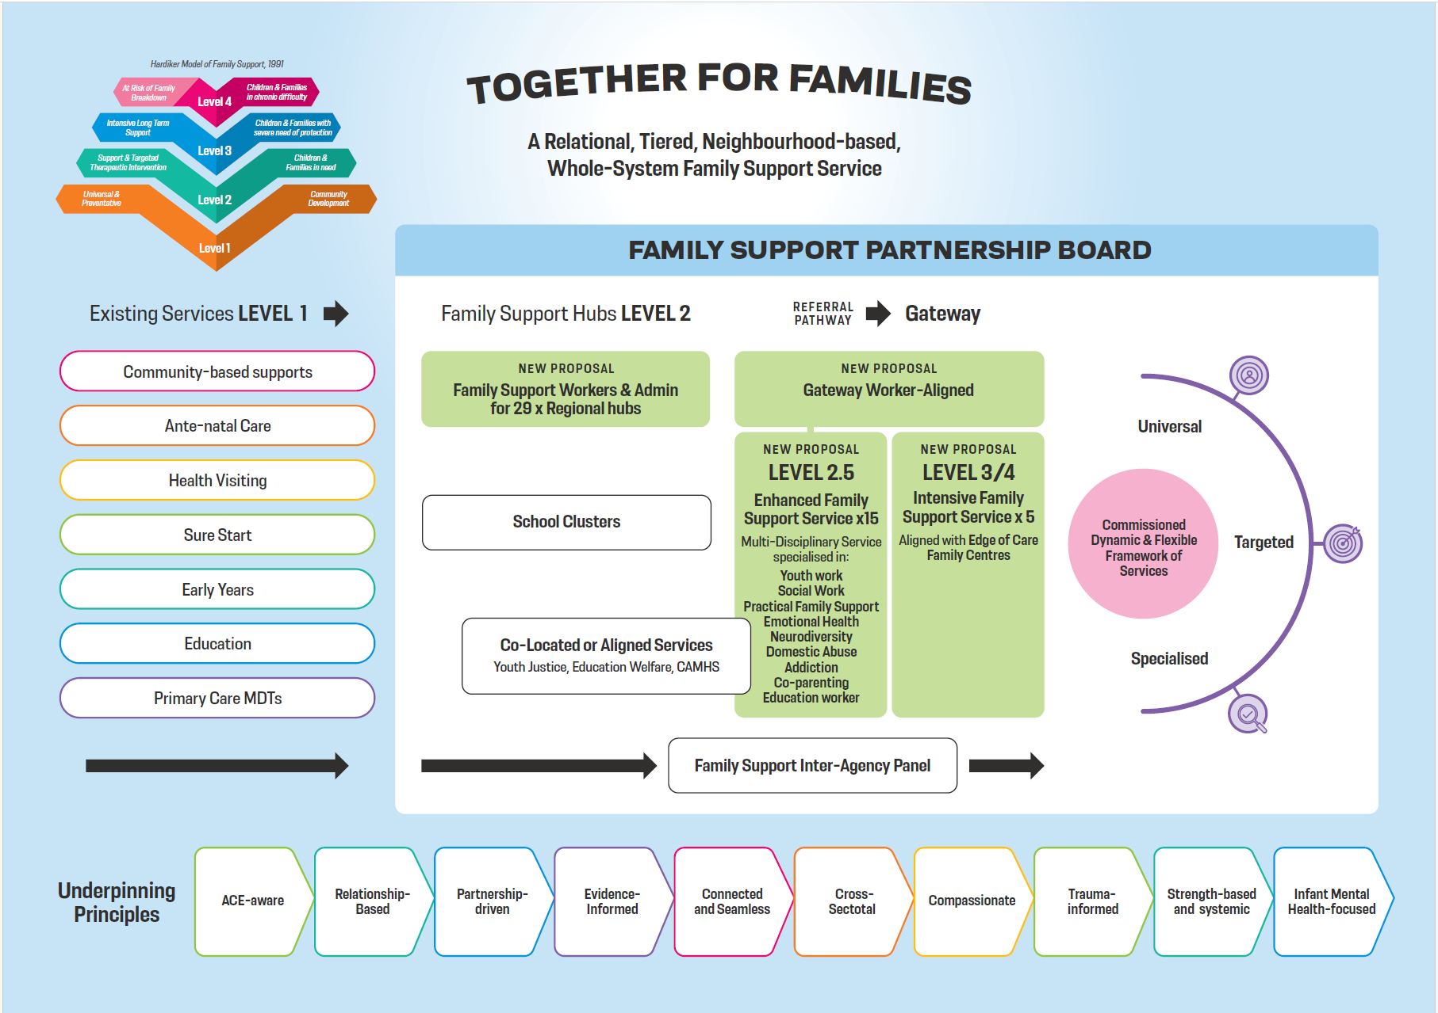

Programme Manager
An exciting opportunity has arisen to lead this dynamic, innovative new transformation programme to help improve the lives of children and young people across Northern Ireland.

The Programme Manager is a highly specialist role with responsibility for implementing the Together For Families model on a partnership basis across the statutory and voluntary and community sectors. The Programme Manager will be expected to work in line with the vision and principles of the model - to provide an integrated, tiered, needs-responsive, seamless service that prioritises early intervention and prevention while also promoting and facilitating family and community resilience.

The Programme Manager will be responsible for strategic planning and delivery of the Model. Among other things, this will require the establishment and management of inter-agency and multi-disciplinary partnerships operating at regional and local levels. Ensuring that the views of children, young people, parents and carers are fully embedded into all planning and delivery processes which will be critical to the success of the programme.

Alongside key stakeholders, the postholder will be responsible for developing a clear implementation plan including: recruitment of programme staff, establishing programme structures, service implementation which may include procurement and competitive grant aid processes. The role will also include the development of operational policies and guidance, where necessary.
Other critical areas of work will include programme budget management, the development and management of data flows and the identification and monitoring of agreed outcomes/success measures.
The postholder will be required to manage reporting arrangements to the Children’s Services Strategic Reform Board, the Public Service Transformation Board and the National Lottery Community Fund.

The postholder will be expected to ensure that the principles of the Together For Families model are implemented and adhered to by all partners and lead on culture change and partnership development within and across organisations, ensuring Family Support is the preferred method of intervention with children and Families.

Figure 2
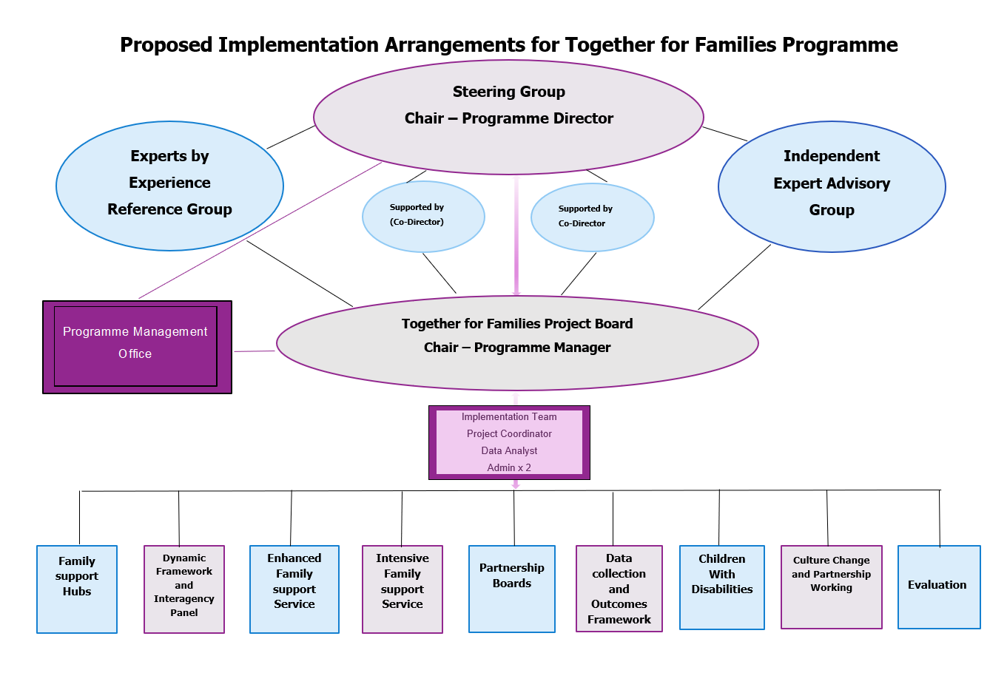

Main objectives of the opportunity

The main objectives are to:

- Lead on delivering the Together For Families model across Northern Ireland.

- Manage the Together For Families Implementation Team, which will include: a Project Co-ordinator, Data Analyst and Administrative staff (x 2), providing clear and strategic leadership to programme staff and demonstrate effective leadership in the wider children’s social care system.

- Lead a significant change management process.

- Ensure effective governance of the programme, including reporting to all relevant programme structures and ensuring the Director for Social Care Reform is kept up-to-date with progress and any barriers to implementation.

- Identify, manage and escalate programme risks as necessary.

- Lead on stakeholder engagement and manage communications.

- Manage Together For Families budget (expected to be in the region of £58.5m over 3 financial years) ensure all financial targets are met and financial viability is maintained, that value for money is achieved and that there is full compliance with standing financial instructions and DOH protocols.

- Design framework and process for the ongoing evaluation of the Together For Families model, including identification of project outcomes and how these will be measured, monitored and reflected in ongoing project implementation.

- Work in collaboration and build effective and compassionate relationships with all programme partners.

- Take on any other additional responsibilities required by the Programme Director.

3. Skills requirements

What qualities, skills and experience are required from the individual

The following are ESSENTIAL and DESIRABLE criteria which will initially be measured at shortlisting stage although may also be further explored during the interview/selection stage. You should therefore make it clear on your application form whether or not you meet these criteria. Failure to do so may result in you not being shortlisted.

ESSENTIAL CRITERIA

- Have a Degree or relevant professional qualification in social work and provide evidence that they are registered with NISCC.

- Experience of working at a senior management* level involving significant responsibility for staff management and budget management.**

- Evidence of delivering on a strategic change/reform initiative impacting a number of stakeholders and evidencing clear outcomes within the past 3 years and meeting a full range of key targets and making significant improvements.

- Demonstrate ability to establish and maintain relationships with a range of statutory and VCSE stakeholders towards achieving successful outcomes.

- Successfully demonstrate high level people management, governance and organisational skills.

- Demonstrate an understanding of the current children’s services social work practice and an understanding of overarching policy context, including in relation to the findings of the Independent Review of Children’s Social Care Services.

- Experience of working in a children’s social care setting at a senior level for a minimum of 3 years.

- Excellent communication skills, both verbal and written.

DESIRABLE CRITERIA
- Experience of project management
- Experience of formal Quality Improvement (QI) processes.
*Experience of working at senior management level for a minimum of 3 years involving significant staff, budget and operational responsibility.

**Experience at this level typically involves experience gained at least at HSC Trust Band 8b or equivalent [Band 8b salary equivalent is £62,215 - £72,293] OR experience that has involved high-level, complex decision making, managing large teams and overseeing multi-million-pound budgets.

ASSESSMENT PROCESS
The selection process will include a presentation and a competence-based interview.
You will be assessed against the following competencies during the interview/selection stage:

- Setting Direction
- Managing a Quality Service
- Delivering at Pace
- Collaborating and Partnering
- Communication/Leadership
- Making Effective Decisions
For more information, please see NICS Competency Framework

PRESENTATION
As part of the interview candidates will be required to make a presentation relevant to the responsibilities of the post. You will receive further information about the presentation when you are confirmed for interview.

4. Personnel: Please state below

Who will be the individual’s line manager and/or reporting officer?
Director of Social Care Reform, Eilís McDaniel – Grade 5

5. Transfer of learning
Please give details of how the opportunity will benefit your organisation, the individual and their organisation.

Benefits for DoH
The Department of Health is proceeding at pace to implement much-needed social care reform. This new programme is a key element of the wider reform programme for children’s social care. Recruiting a manager to lead this new team and implement this model is essential.

Benefits for other departments
Increasingly, there is a need within the public sector to collaborate with colleagues in other departments, local government and external agencies, in order to maximise the resources available and address common goals. It is essential that social care reform teams work collaboratively across organisations for shared benefits. Lessons learnt as part of this process will be helpful in informing the work of other departments and to inform future policy and delivery.

Benefits for the applicant
This post offers the applicant the opportunity to develop the full range of competencies at this senior level such as; Setting Direction, Managing a Quality Service, Delivering at Pace, Collaborating and Partnering, Communication/Leadership, Making Effective Decisions and Delivering Value for Money.
The role offers a unique opportunity to lead a transformational programme to implement much needed change for children and families and influence departmental policy/strategy. Early results have already been achieved in the wider reform programme. The applicant will have the opportunity to contribute to a wide range of social care improvements during the implementation period and address many of the issues identified by the independent Review of Children’s Social Care Services.

6. Logistics
Please provide details of the likely start date, duration, location, form of transport required, resources (i.e. desk, PC, etc.) and funding arrangements for the opportunity.

Start Date: April 2026

Duration: 3 years with the possibility of an extension subject to funding.

Location: Castle Buildings, Stormont. Hybrid working arrangements will be available (40% office, 60% home).

Resources: People and Funding

Funding: DoH will meet the salary and any associated costs for the role. The successful candidate will be seconded to a NICS Grade 6 post in DoH. While the normal salary range for NICS Grade 6 is £73,577- £77,904, there may be some room for negotiation on salary, which will be agreed upon prior to appointment.

Further information: please contact Deirdre Mahon on Deirdre.Mahon@health-ni.gov.uk

Closing Date: Applications must be submitted by 5.00pm on 27 February 2026 to: interchangesecretariat@finance-ni.gov.uk

7. Endorsement

Interchange Manager

Eilís McDaniel
Signed:

06 February 2026
Date:

