Hosting Proforma
Department of Health

Name of Host
Organisation

1. Interchange Manager’s details
Eilís McDaniel
Name

Organisation/
Social Care Reform Directorate
Department
Castle Buildings
Stormont
Address

Telephone Fax
028 9052 3263

Number
Eilis.McDaniel@health-ni.gov.uk

E-mail

Type of Opportunity
Secondment – Social Care Reform, Programme Coordinator – Programme Governance – Grade 7 (broadly similar to Agenda for Change Band 8a level)

2. Details of hosting opportunity

Description of opportunity

Background
The Department of Health is leading a programme of work on service improvement and the delivery of transformation in Health and Social Care. The Department commissioned an Independent Review of Children’s Social Care Services, led by Professor Ray Jones, in response to significant challenges being experienced by children’s social care services in Northern Ireland including, high numbers of children and families waiting for help, persistent issues within the children’s social care workforce and unprecedented numbers of children in care. The report of the Independent Review was published in June 2023 and the Minister of Health accepted 34 of the recommendations.

The Children’s Social Care Services Reform Programme was established in April 2023 in advance of the Review reporting, to begin to address the challenges within children’s social care that led to the Review being initiated and were confirmed by it. The Reform Programme is led by DoH and overseen by a Programme Board made up of senior leaders within children's social care and other government departments. 25 of the Review recommendations are being progressed by the Reform Programme, including recommendations to improve support for families at an earlier stage as an alternative to high levels of protection activity by HSC Trusts.

Through the work of the Reform Programme (specifically Workstream 9), a new Northern Ireland family support model, Together For Families, has been developed. Under the model, services to families would be provided in an integrated, seamless and co-ordinated way along a continuum of need.

Together For Families Model
The key aim of the model will be to prevent children having to enter the statutory system of service provision, either through child protection planning or being taken into care and, when they do, to enable them to return home as quickly and safely as possible where appropriate.

Together For Families is a significant transformation project over 3 years. The model will deliver a number of changes to how families experience services:

- Enhancements to Family Support Hubs (through the introduction of Family Support Workers and administrative support).
- The introduction of a new level of service for families who have higher level of need (an enhanced service) but do not meet the threshold for statutory intervention.
- The introduction of a new service within HSC Trusts (an intensive service) targeted at children and families already known to Trusts to prevent entry into care or enable the safe return home from care.
- A new innovative approach to providing access to additional services not provided through other parts of the Together for Families model through an Inter-agency panel, chaired by the relevant HSC Trust, which will hold the service budget.
- The establishment of regional and local multi-sectoral, multi-agency Partnership Boards to oversee delivery of the new model throughout the initial implementation (transformation) period.

Figure 1
The Together For Families Model of Family Support

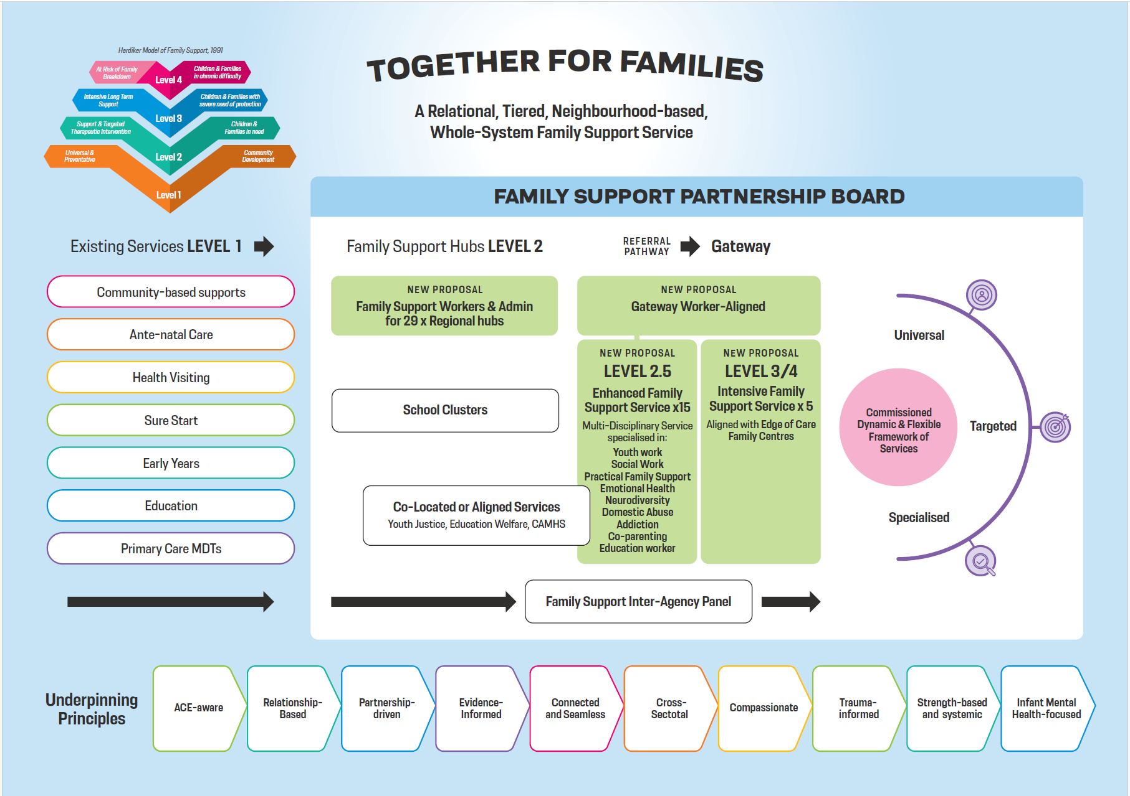

Programme Coordinator

An exciting opportunity has arisen to undertake a coordination role in implementing this dynamic, innovative, new transformation programme to improve the life chances of children and young people in Northern Ireland.

The Programme Coordinator will be part of an Implementation Team that is being established to deliver on Together for Families and will be responsible for assisting the Programme Manager in the strategic planning and delivery of the model. Among other things this will require effective inter-agency and multi-disciplinary partnerships operating at regional and local levels. Ensuring that the views of children, young people parents and carers are fully embedded into all planning and delivery processes will be critical to the success of the Programme.

The Programme Coordinator will be responsible for assisting the Programme Manager in developing and maintaining a clear implementation plan including establishing programme structures, service implementation which may include procurement and competitive grant processes, and the development of operational policies and guidance where necessary. Other critical areas of work will include programme budget management, the development and management of data flows and the identification and monitoring of agreed outcomes / success measures. The post will also include supporting in reporting to the Children’s Social Care Services Reform Board, the Public Sector Transformation Board and the National Lottery Community Fund.

The postholder will support the Programme Manager in embedding the principles of Together for Families and family support as the preferred method of intervention with children and families across children’s social care partners.

The Together for Families Implementation Team will be overseen by the Director for Social Care Reform and will work closely with 2 Co-Directors who have been engaged to lead on implementation of reform in the voluntary and community and statutory sectors. The Team will sit within the Social Care Reform Directorate in the Department of Health and will be supported by the Social Care Reform Programme Management Office.

Main objectives of the opportunity

- Support the Programme Manager in leading a significant change management process to deliver the Together for Families model across Northern Ireland.

- Support Programme Manager in establishing and maintaining effective programme governance, including: mechanisms for tracking progress, risk / issue management and outcomes measurement; oversight of organisation of Steering Group, Project Board and Experts by Experience Group; reporting to Children’s Social Care Services Reform Programme Board, Public Sector Transformation Board and National Lottery Community Fund.

- Assist in budget management in collaboration with the Social Care Reform Programme Management Office (expected to be in the region of £59.2m over 3 financial years) to ensure value for money and compliance with DoH protocols.

- Oversee programme communication and engagement, including the Together for Families webpages.

- Establish and maintain effective working relationships with workstream leads, the Social Care Reform PMO and a range of key stakeholders.

- Line management responsibility for 2 Programme Support Officers (NICS 1xStaff Officer and 1xDeputy Principal grades).

- The post holder may be required to carry out other duties as directed by the Programme Manager.

3. Skills requirements

What qualities, skills and experience are required from the individual

The following are ESSENTIAL and DESIRABLE criteria which will initially be measured at shortlisting stage although may also be further explored during the interview/selection stage. You should therefore make it clear on your application form whether or not you meet these criteria. Failure to do so may result in you not being shortlisted.

ESSENTIAL CRITERIA

- Relevant bachelor’s degree or equivalent qualification, for example, social work, youth work, community work, education, business management, ICT.

- Minimum three years’ experience involving effective project and budget management.
- The ability to ensure coherence between strategic intent and service delivery.

- Demonstrate commitment and skill in inter-agency work and a community development approach to service delivery.

- Ability to act on own initiative and work independently.

- Proven organisational and project management skills including implementation planning and risk management skills.

- Strong leadership and people management skills.

- Ability to build and maintain effective working relationships with a range of key stakeholders, encourage contributions from diverse sources and influence change.

- Excellent communication skills, both verbal and written, including ability for constructive challenge and dialogue.
- Excellent analytical skills – using data and evaluation to identify challenges and develop solutions and to inform decisions.

- Ability to implement change, delivering at pace.

- Good understanding of current children’s services social work practice, policies and procedures, children’s social care landscape in Northern Ireland, and an understanding of overarching policy and legislative context, including in relation to the findings of the Independent Review of Children’s Social Care Services.

DESIRABLE CRITERIA

- Certification in PRINCE2 or other recognised project management methodology.

ASSESSMENT PROCESS
The selection process will include a paper sift. It is therefore important that applicants provide evidence which demonstrate that they meet the eligibility criteria set out above. Following the initial sift, the top 5 candidates may be called for a competence-based interview.

Applicants invited for interview will be assessed against Grade 7 competencies from the NICS competency framework as set out below:

Setting Direction
- Changing and Improving
- Making Effective Decisions
Engaging People
- Leading and Communicating
- Collaborating and Partnering
Delivering Results
- Delivering at Pace
- Achieving outcomes through delivery partners.

For more information, please see NICS Competency Framework

4. Personnel: Please state below

Who will the individual report to?
Programme Manager

5. Transfer of learning
Please give details of how the opportunity will benefit your organisation, the individual and their organisation.

Benefits for DoH
The Department of Health is proceeding at pace to implement much-needed social care reform. This new programme is a key element of the wider reform programme for children’s social care. Recruiting a Programme Coordinator to support lead this new team and implement this model is essential.

Benefits for other departments
Increasingly, there is a need within the public sector to collaborate with colleagues in other departments, local government and external agencies, in order to maximise the resources available and address common goals. It is essential that social care reform teams work collaboratively across organisations for shared benefits. Lessons learnt as part of this process will be helpful in informing the work of other departments and to inform future policy and delivery.

Benefits for the applicant
This post offers the applicant the opportunity to develop the full range of competencies at this senior level in the following domains: Setting Direction, Engaging People and Delivering Results.
The role offers a unique opportunity to have a leading role in a transformational programme to implement much needed change for children and families and influence departmental policy/strategy. Early results have already been achieved in the wider reform programme. The applicant will have the opportunity to contribute to a wide range of social care improvements during the implementation period and address many of the issues identified by the Independent Review of Children’s Social Care Services.

6. Logistics

Start Date: Within two months of the decision to accept the post.

Duration: 3 years with the possibility of an extension subject to funding.

Location: Castle Buildings, Stormont, although it may be possible to negotiate an alternative base. Hybrid working arrangements will be available (40% office base, 60% home).

Resources: People and Funding

Funding: DoH will meet the salary and any associated costs for the role. The successful candidate will be seconded to a NICS Grade 7 post in DoH. As a guide, the salary range for NICS Grade 7 is £61,673-£64,469. However, the successful candidate is expected to be seconded on their existing terms and conditions, including salary.

Further information: please contact Deirdre Mahon Deirdre.Mahon@health-ni.gov.uk or Jacinta Linden Jacinta.Linden@health-ni.gov.uk.

Closing Date: Applications must be submitted by 5.00pm on 15 May 2026 to:

interchangesecretariat@finance-ni.gov.uk

*This opportunity is not open to NICS staff

7. Endorsement

Interchange Manager

Eilís McDaniel

Signed:

23 April 2026
Date:

