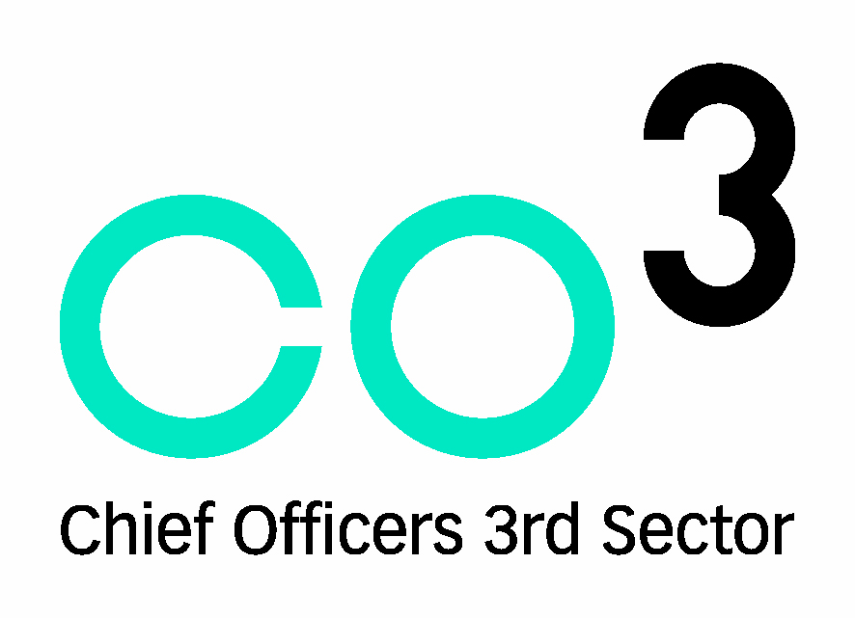
|CO3 Mentoring Programme

CO3 Chief Officers Third Sector is a membership organisation for leaders in the Charity Sector here in Northern Ireland. CO3 has a network of over 800 members made up of CEOs, Senior Managers and Trustees. Our members include the Leaders of Northern Ireland’s most established leading charities and social enterprises.

CO3 offer a wide range of support to our members including training, peer networking events and support services. As part of this package we offer a mentoring programme.

The CO3 Mentoring Programme is a leadership development service to enable leaders from the Charity Sector to benefit from the experience and knowledge of their peers, either from within the Charity Sector or from the Public and Private sectors.

What is Mentoring?

Mentoring is a highly successful development tool at senior executive level because it is tailor-made to suit the individual. The Mentee (person being mentored) is able to discuss issues/experiences in a safe and confidential environment. The Mentor can share experience and best practice and provides a sounding board to the Mentee. At CO3, we know that by participating in the programme the leadership capacity of both the Mentor and Mentee is enhanced.

Who does the programme support?

The programme is designed for chief executives and senior managers in the Third Sector to support their leadership development and improve their performance. The Programme aims to provide mentees with a confidential and safe environment to develop their leadership abilities. Mentors will also benefit from taking part by further enhancing their communication, interpersonal, problem-solving and listening skills.

Why get involved as a Mentor

We are looking for experienced senior executives from the Private, Public and Third sector to get involved as a Mentor in the CO3 Programme

We are looking for Mentors with the following attributes:
• a willingness to listen and to share their knowledge and experience
• a keen interest in others and a willingness to share their successes and failures (i.e. they do not claim to be perfect!)
• an open-minded point of view and enthusiasm to explore new ideas or ways to do things differently.

The Benefits of getting involved as a Mentor are:

- Free Personal Development – As part of the programme you will receive training on how to be a Mentor and your own soft skills will be enhanced.
- Time to Reflect – Mentoring gives you a great opportunity to reflect on your own self awareness and leadership style and as a result be a more effective leader.
- The “Pass it on” Effect – Helping another person and seeing them develop and grow in confidence is very rewarding
- Recognition – you and your organisation will gain recognition for helping develop leadership in the Sector and is a great way to meet some of your Corporate Social Responsibility objectives
- Challenge – A Mentee can challenge you in a way that perhaps your own staff may not be able to, as they are not a direct report.

When will it start?
We start to recruit for the mentoring programme at the start of each year.
We will be running a Mentoring Information Session on Tuesday 12 Feb 2019, 11am-12pm with the formal induction starting in April.

What’s the time commitment?
Leaders are matched with other leaders for a 12 month period.
Mentors will be asked to meet with their Mentee approximately every 4-6 weeks over the 12 month period.

How am I matched with a Mentee?

We ask all our Mentors to complete a Mentor Profile form which you complete with details about your work background and your areas of knowledge and skills. We use this profile form to match you with a Mentee who has requested support in a specific area.

Will I receive any training?
Yes both Mentees and Mentors are invited to attend an informal information session to find out generally what the programme is about. Then, once we know you want to commit to the programme, you will be asked to attend a training session when you will meet the other Mentors and we will take you through what is expected of you as a Mentor.

What support will I receive as a Mentor?
CO3 has a dedicated mentoring co-ordinator who supports the mentoring relationships through the year. This co-ordinator provides you with support and independent advice about your role with any queries about your mentoring relationship.
CO3 also provides you with a comprehensive Mentoring Guide to refer to throughout the programme.
CO3 offers you the opportunity to become an Associate Member of CO3 which provides you with insight and support around the sort of issues a charity leader may be dealing with, and to attend our many free networking events throughout the year.
In addition to the initial training you will also be invited to a 6 month re-connect session with your peer mentors and a final re-connect session to help you to share your learning and to formally end the mentoring relationship.

Is there a cost?
No! There is no cost to being a Mentor and CO3 will also cover any travel costs* you incur as the result of your mentoring role.

What if I have missed the start of the formal programme?
For those people who approach CO3 to become a Mentor during the year we run an ad hoc matching service. We can provide you with a one to one induction session and then add you to our “Mentor Bank” and match you as and when we get a request from a Mentee.
How do I sign up?
For more information on how to sign up to the programme please contact Tracey McCreanor at CO3. Tel: 02890245356 or email Tracey@co3.bz

Quotes from Past Mentees:
“My Mentor took the time to really listen to me; he created a safe confidential space where I felt at ease sharing my issues and receiving critical and thoughtful comments on how to consider the situation / proceed with the situation. He was so gracious and really offered a reflective mirror for me to view change. He was kind and considerate, but never afraid to pose the really meaningful questions which can give new insights for someone working their way through the situation.”
“This is the best thing CO3 has ever done – thank you so much for the opportunity”
“I have had a hugely positive experience and learnt so much from my mentor”

“My ‘conversations with purpose’ with my mentor have been invaluable – not just for my own development but also for the development of my organisation”

“My mentor genuinely provides a different perspective, actively listens and
questions. We have set tasks and a focus for each meeting which makes
me take time to look at, for example, my leadership challenges more
theoretically.”

“My Mentor is so easy to talk to and has extensive experience in the areas that I need to discuss”

*We ask our mentoring partners to keep travel costs to a minimum where possible. The total travel costs a mentor can claim are capped as per the CO3 Volunteer Policy

