NI INTERCHANGE SCHEME

# Hosting Opportunity Proforma

Belfast Metropolitan College (on behalf of Belfast Region City Deal)

Name of Host

Organisation

**1. Interchange Manager’s details**

Kathryn Mallon

Name

Organisation/

HR Department

Department

Montgomery Road

Belfast

BT6 9JD

Address

02890 265370

Telephone

Number

[Kathrynmallon@belfastmet.ac.uk](mailto:Kathrynmallon@belfastmet.ac.uk)

E-mail

Type of Opportunity

3 year Secondment on Employability and Skills

**2. Details of hosting opportunity**

Description of opportunity

**Programme Manager Belfast Region City Deal Employability & Skills**

Opportunity for 3 year secondment with possible extension to the Belfast Region City Deal Programme Office. 4 FE Colleges are leading on the employability and skills elements of this exciting programme which represents an £850 million investment over the next 10 years.

A Candidate Brief is available at Annex A.

Main objectives of the opportunity

* To support the development of the business case which will underpin the delivery of the Employability & Skills Programme within the City Deal
* To ensure that all investment projects consider and develop appropriate strategies to address skills issues
* To work closely with Council, Colleges and collaborating Departments to develop a programme fo work to delivery skills and employability interventions

**3. Skills requirements**

What qualities, skills and experience is required from the individual

General

* Understanding of skills and employability issues
* Previous project or programme management experience
* Interest in working on collaborative programme with Colleges and Councils

Essential

Applicants **must**, as at the closing date for receipt of application forms, have a third level qualification in a relevant subject or within a relevant professional discipline, or an equivalent qualification.

Applicants **must**, as at the closing date for receipt of applications, be able to demonstrate, by providing personal and specific examples on the application form, at least two years’ relevant experience of the effective leadership, management and delivery of economic development, skills or employability projects or programmes.

This project/ programme management experience must also include relevant experience of:

1. effective programme or project governance and risk management including managing and monitoring programme or project budgets, while ensuring high standards of financial administration and probity;
2. building and maintaining effective collaborative relationships with a range of internal and external stakeholders and analysing and resolving complex issues involving different end- users and stakeholders while displaying effective judgement; and
3. identifying synergies and interdependencies between programmes or projects to target opportunities to maximise delivery and value for money.

**4. Personnel: Please state below**

Who will the individual report to?

Programme Director in Belfast Region City Deal Programme Office – located in Belfast City Council – working on behalf 4 FE Colleges – Belfast Met, NRC, SERC and SRC. A so requires regular progress updates to FE Principals Group and BRCD Employability and Skills Programme Board.

Who will be the individual’s line manager and/or reporting officer?

Programme Director BRCD Programme Office

**5. Transfer of learning**

Please give details of how the Opportunity will benefit your organisation, the

individual and their organisation.

This is a unique opportunity for the appropriate candidate to work on a collaborative programme between the Colleges, Councils and key Departments on a major investment programme to support skills and employability.

**6. Logistics**

Please provide details of the likely start date, duration, location, resources (i.e.;

desk, PC, fax etc.) and funding arrangements for the opportunity.

|  |
| --- |
| **Start Date**: As soon a suitable candidate has been identified and a release date agreed.  **Location**: The successful candidate will be based at BRCD Programme Office Belfast City Council, City Hall, Belfast  **Equipment**: PC and all workstation requirements covered by BRCD Programme Office  **Travel**: Travel to various locations throughout NI may be required and all local and national travel expenses will be covered by BRCD Programme Office  **Funding**: Salary costs covered by joint funding from 4 FE Colleges and the salary range is: £50,172 - £52,935.  **Closing Date:** Applications must be submitted by **5.00pm on Friday 27th September** **2019** to**:**  **For NI Civil Service departmental staff only:** [**secondments@hrconnect.nigov.net**](mailto:secondments@hrconnect.nigov.net)  **For staff from all other Partner organisations:** [**interchangesecretariat@finance-ni.gov.uk**](mailto:interchangesecretariat@finance-ni.gov.uk) |

**7. Endorsement**

**Interchange Manager**

Kathryn Mallon

Signed

16th September 2019

Date

Annex A



**Programme Manager**

**Employability & Skills**

**Belfast Region City Deal**

**Candidate Brief**   
September 2019

**.……………….………………………………………………….**

**Table of Contents**

Foreword from the Chair of BRCD Employability and Skills Board 3

Background: Belfast Region City Deal 4

BRCD Governance Structure 5

Job Description 6

Personnel Specification 10

Application Process 11

Key Dates 11

Selection Process 12

Provisional Assessment & Interview Dates 12

Engagement Process 12

Reserve List 13

Feedback to Candidates 13

Competency Framework 15



## Foreword from the Chair of BRCD Employability and Skills Board

Dear Candidate

On behalf of the BRCD partners, I am delighted you are interested in this job of Programme Manager Employability & Skills – Belfast Region City Deal. This is one of the most exciting jobs in the public service and provides a unique opportunity for the successful candidate to be the key facilitator of the employability and skills programme, between Colleges, Universities, Councils and core Departments, which is an integral part of the Belfast Region City Deal. Working on behalf of Belfast Met, Northern Regional College, South Eastern Regional College and Southern Regional College, in collaboration with 6 Local Councils, this role will be key to the overall success of the BRCD.



The Belfast Region City Deal is an unprecedented partnership with a number of key stakeholders who have come together to deliver an integrated programme of investment that will transform the economy of the region. The agreed programme will seek to address a number of key barriers to growth by taking measures to improve productivity, invest in innovation, tackle economic inactivity and deprivation, address skills gaps and inequalities, invest in additional world class visitor experiences and develop next generation physical and digital infrastructure.

The announcement in March 2019 of the £350 million investment from Treasury for the Belfast Region City Deal, with the NI Executive expected to add a further £350 million, and councils and universities contributing approximately £150 million, is matched by a commitment from the Colleges and Councils to align an additional £30 million to support Employability and Skills.

As the Programme Manager for Employability and Skills you will work with the BRCD Programme Office leading the actions required between the Council, Colleges and other stakeholders to deliver on the ambitious E&S Agenda. You will work across all 6 Councils, Colleges, Universities, anchor institutions and the private sector. You will also build collaborative working relationships across the partnership and with Members, partners, stakeholders, government departments, agencies, and businesses across all strands of the programme.

If you see your future career ambitions reflected in our ambitious programme, we would very much welcome your application.



**Marie-Thérèse McGivern**

**Principal & Chief Executive, Belfast Met**

**CHAIR, Employability & Skills Programme Board**

## Background: Belfast Region City Deal

In October 2018, the Chancellor of the Exchequer announced that Northern Ireland will receive a £350m investment from the Exchequer in the form of a City Deal for the Belfast Region. City Deals are bespoke packages of funding and decision-making powers negotiated between central government and local authorities.

The Belfast Region City Deal (BRCD) comprises the six councils of Antrim and Newtownabbey Borough Council, Ards and North Down Borough Council, Belfast City Council, Lisburn and Castlereagh City Council, Mid and East Antrim Borough Council and Newry, Mourne and Down District Council, working in partnership with Queen's University Belfast and Ulster University, Belfast Metropolitan College, Northern Regional College, South Eastern Regional College and the Southern Regional College.

It is hoped the deal will create up to 20,000 new and better jobs alongside delivering a 10 year programme of inclusive economic growth – including an increase of £470m Gross Value Added (GVA).

The Treasury announcement forms part of a £850 million co-investment package for the city region. It is also anticipated that direct investment from the private sector will take the overall package for inclusive growth to well over £1 billion. The six Belfast Region City Deal partner councils have committed £100 million investment, with Queen’s University and Ulster University having committed £50 million.

The four pillars of our ambitious proposition include:

* + Innovation and digital
  + Tourism-led regeneration
  + Infrastructure
  + Employability and skills

In addition, regional Further Education Colleges and Councils, will deliver a complementary employability and skills interventions with a commitment to a £30 million programme to ensure that people gain the necessary skills to secure and deliver on the new and better paid jobs that will be created as a result.

For more information on Belfast Region City Deal please click the following link: <https://youtu.be/pvflJTjN-I4>

## BRCD Governance Structure

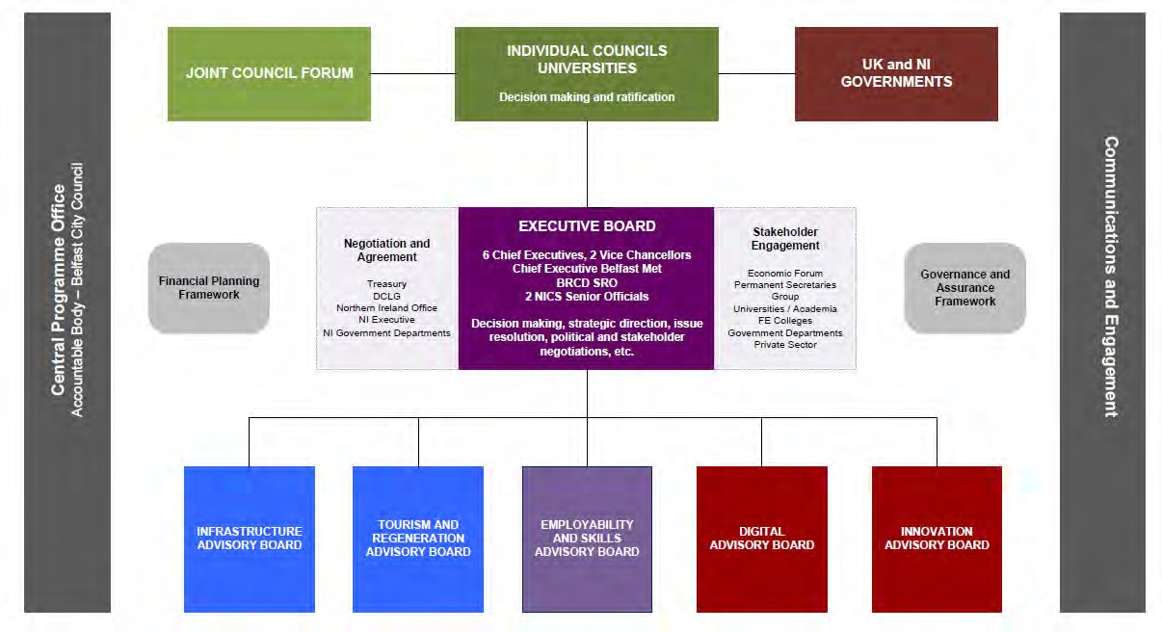

Job Description

Department:BRCD Programme Office

Post Reference:2019/149A

Job Title: **BRCD Programme Manager Employability and Skills**

Reporting To:Programme Director, City Deal Programme Office

Grade:Band 12 (£50,172 to £52,935 per annum)

Duration:This is a permanent position however, shorter term secondments (with the possibility of extension) are welcome.

# Main purpose of job

To be responsible to the Programme Director of the Belfast Region City Deal Programme Office, working with the other City Deal Programme Managers through the effective development and delivery and professional oversight of all designated programmes and projects related to the Employability and Skills proposition for the Belfast Region City Deal (BRCD). Working closely with the collaborating FE Colleges to lead on the development of employability and skill solutions and the alignment of funding to deliver a skills and employability pipeline.

The Programme Manager Employability and Skills will work within the overall City Deal context taking into account relevant skills and employment priorities for partner FE Colleges, ensuring all allocated budgets are managed efficiently and effectively in accordance with Council and College policies, financial regulations, standing orders and external funding protocols, and ensuring propriety and regularity are applied with particular emphasis on value for money.

An important aspect of this role will be the development of effective relationships with a wide range of stakeholders both within the Belfast Region, across the collaborating FE Colleges, UK government departments, local Government, the NI Executive, NICS departments and the private and community sector. Ongoing engagement with the private sector to develop an informed understanding of the specific skills needs underpinning the City Deal will also be an important part of this role.

# Summary of responsibilities and personal duties

# Leadership and Management

* To provide ongoing management support and oversight of a range of programmes and projects as they relate to employability and skills aspects of the BRCD.
* To lead on the preparation of the employability and skills programme business case in co-ordination with key stakeholders and funding bodies to ensure that the skills pipeline is aligned to the capital investment programme.
* To provide the BRCD Programme Director and other appropriate Senior management members, working groups or external bodies with a level of assurance that propriety and regularity are being applied to all funding.
* To support council departments and Colleges in the identification and delivery of relevant regional skills and employment priorities using collaborative approaches and funding sources.
* To support the planning, co-ordination and reporting activities required across College teams to ensure that City Deal priorities are clearly aligned with College Development Plans.
* To lead on private sector engagement to stimulate demand for career-based training and to enhance skills forecasting across the City Deal region.

**Project Management and Performance**

* To formulate, organise and maintain effective programme and project management arrangements to secure the effective delivery of allocated strategic programmes of work as agreed by Councils, Colleges and Programme Board as they relate to the Employability and Skills Proposition.
* To agree appropriate performance indicators and monitor progress towards targets.
* To produce timely committee, briefings, performance management and financial reports and papers and to attend committees, corporate management teams, project boards etc. as and when required.
* To develop, manage, monitor and review appropriate programmes and project performance management frameworks and risk registers, allowing key stakeholders to be kept informed of progress against targets.
* To be responsible for the effective management of all appropriate programme and project governance arrangements including all relevant systems and processes.
* To ensure all financial, legal, procurement, design and other technical inputs for each programme are fit for purpose and in line with appropriate regulations, Council and College policies and standing orders.
* To oversee internal delivery or external procurement of economic appraisals in support of business cases to deliver relevant elements of the corporate strategic programme as required.
* To review and quality assure programme and project risk management arrangements, building capacity needed to maximise delivery.

**Engagement and Communications**

* To ensure there is comprehensive and pro-active partner and stakeholder engagement across partner agencies, local councils, business, and other sectors.
* To provide regular updates to the Principals Group of the FE sector ensuring close co-ordination with curriculum, business and finance teams in collaborating Colleges
* To develop and deliver an effective communications strategy so that key partners and other stakeholders understand the City Deal employability and skills priorities and the reasons for them.
* To represent the City Deal at appropriate groups, meetings and events.
* To provide a point of contact for those external bodies seeking to engage with the BRCD City Deal Employability and Skills priorities.
* To develop and maintain effective working relationships and partnerships between and with council departments, college sector working groups, member/officer groups and committees, government departments and statutory bodies on matters affecting programme and project delivery.
* To undertake the duties in such a way as to enhance and protect the reputation and public profile of the BRCD Employability and Skills Programme.
* To develop an engagement strategy to co-ordinate with other training providers including community based training provision to develop a skills pipeline, linking into the community planning agenda as needed.

**Budgets and Financial Management**

* + To lead on the business planning and budgeting processes connected to the Employability and Skills programme working with Councils, Colleges, other stakeholders and accountable Departments.
  + To ensure the proper and effective planning and oversight of all E&S resources financial planning and other management controls whilst ensuring efficient utilisation of physical and financial resources that safeguards public funds within area of responsibility.
  + To manage and ensure financial accountability for agreed annual operating budget for area of responsibility ensuring budget holders spend the budgets allocated to them in line with appropriate financial management and control guidelines.
  + To monitor and review budgets and spend profiles against targets and take prompt corrective action to address any areas of overspend.
  + To contribute to the planning and development of appropriate internal and external service level agreements including scope of services, delivery timescales, performance targets, reporting and governance arrangements.
  + To take the lead on preparation of business cases and procurement documents to secure additional capital equipment and investment in line with agreed curriculum needs.
  + To ensure the effective management of risks through the implementation and monitoring of related policies and procedures.
  + To take remedial action in a timely manner with relevant partners and City Deal programme managers and College counterparts where budgets are not being correctly managed.

This job description has been written at a time of significant organisational change and it will be subject to review and amendment, as the demands of the role and the organisation evolve. Therefore, the post-holder will be required to be flexible, adaptable and aware that s/he may be asked to perform tasks, duties and responsibilities which are not specifically detailed in the job description but which are commensurate with the role.

* **Further Education is an ever changing service and all staff are expected to participate constructively in College activities and to adopt a flexible approach to their work.**
* **Note: No job description can cover every issue that may arise within this post at various times and the post holder is expected to carry out other duties which are broadly consistent with those contained in this document. The job description will be reviewed and varied periodically by Management in the light of the business needs of the College.**

**The post is a Previously Controlled Activity Position as defined by the Safeguarding Vulnerable Groups NI Order 2007.**

**Belfast Metropolitan College is a child-care organisation and complies with the requirements of the Protection of Children and Vulnerable Adults Regulations**

SOC 1 – SEPTEMBER 2019

Personnel Specification

**Essential criteria**

**Qualifications**

Applicants **must**, as at the closing date for receipt of application forms, have a third level qualification, or an equivalent qualification.

**Experience**

Applicants **must**, as at the closing date for receipt of applications, be able to demonstrate, by providing personal and specific examples on the application form, at least two years’ relevant experience of the effective leadership, management and delivery of economic development, skills or employability projects or programmes.

This project/ programme management experience must also include relevant experience of:

1. effective programme or project governance and risk management including managing and monitoring programme or project budgets, while ensuring high standards of financial administration and probity;
2. building and maintaining effective collaborative relationships with a range of internal and external stakeholders and analysing and resolving complex issues involving different end- users and stakeholders while displaying effective judgement; and
3. identifying synergies and interdependencies between programmes or projects to target opportunities to maximise delivery and value for money.

**Desirable Criteria**

In addition to the above qualifications and experience, Belfast Met reserves the right to short-list only those applicants who can demonstrate by way of personal and specific example that their relevant experience at both a) and b) have directly contributed to the achievement of relevant sustainable outcomes related to skills and employability projects or programmes.

General Information for Candidates

**Application Process**

Candidates wishing to apply for this role must do so by using the designated online application form. Applications will only be accepted online and not in any other format. Please note CVs are not accepted.

Any candidate who requires the application form in an alternative format due to a disability should contact HR by email to [HRD@belfastmet.ac.uk](mailto:HRD@belfastmet.ac.uk) or by telephoning 02890 265370 for further information.

Candidates are required to fully demonstrate on their application form how they meet the essential criteria for the role they wish to apply in the ‘Essential Criteria’ section of the application form. Failure to do so will mean that the panel will be unable to shortlist you for interview. The College recommends that candidates should read the *Candidate Guidance – How to complete your Application Form* document to fully understand the information that is required from you.

It is the responsibility of all candidates to ensure that completed application forms are received by the HR Department by the closing date and time specified. Candidates should note that the system will close live jobs at the stroke of 12.00 noon. Late applications received by the College after the specified date and time will not be considered in this process. The closing time and date for applications is **not later than 12.00 noon on Friday 27 September 2019.**

**Key Dates**

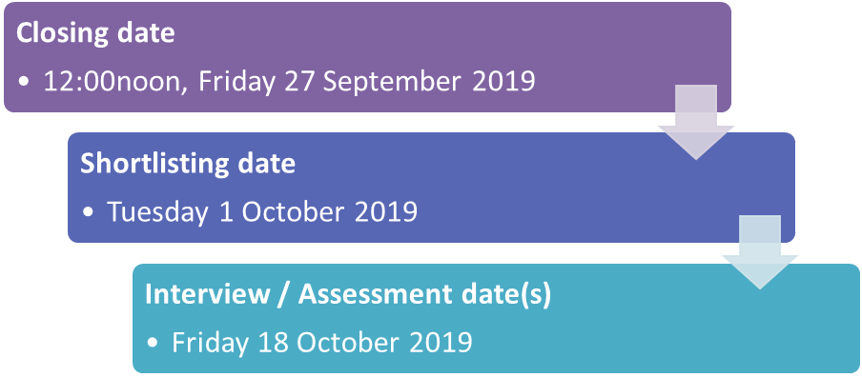

**Shortlisting Process**

All completed applications will be assessed by a selection panel against the selection criteria relevant for the role.

Please note that the selection panel can only shortlist based on the information candidates provide on the application form and cannot make any assumptions based on any prior or personal knowledge.

The provisional date for panel shortlisting is **Tuesday 1 October 2019.** All candidates will be notified as to the outcome of the shortlisting process.

*In the event of an excessive number of applications, the panel reserves the right to enhance the* *shortlisting criteria.*

**Selection Process**

Should a shortlisted candidate still wish to progress, they must attend an interview and/or assessment to fully demonstrate how they meet the criteria for the role. The interview will be by competency based assessment. The selection process may also comprise of other assessment methods depending on the role.

Assessments may consist of a range of techniques. These could be group exercises, simulated exercise, role-play, presentation, psychometric testing, written or computer based exercises.

Details of the assessment will not typically be provided to candidates in advance unless the assessment requires advance preparation e.g. seen presentation topic.

**Provisional Assessment & Interview Dates**

***Regrettably, we will be unable to reschedule interviews for candidates and if a candidate does not attend for interview, we will then assume that they have withdrawn from the process.***

It is anticipated that assessment and interviews will be held as follows:

* **Friday 18 October 2019**

Please note, this/these date(s) may be subject to change dependent on panel availability.

Candidates should note that the College does not reimburse costs incurred by them travelling for interview and assessment.

**Engagement Process**

To be appointed to the College, all candidates that pass the assessment process will be required to go through an AccessNI Enhanced Disclosure Criminal Record Check of which a fee of £33, payable by the candidate. See AccessNI’s web site for further information [www.accessni.gov.uk](http://www.accessni.gov.uk)

Successful candidates will also be required to complete the following activities:

* Satisfactory completion of a confidential medical pre-placement questionnaire and, if necessary, an examination by an occupational health advisor/physician; Receipt of documentary evidence of qualifications (if applicable);
* Receipt of satisfactory references (see application form), and any gaps in your employment history being satisfactorily explained;
* Presentation of documentation relating to eligibility for employment in the UK;
* Any other requirements which the College deems necessary.

All these checks require to be completed in advance of any engagement for work. Upon satisfactory completion of all of the elements outlined above, candidates be contacted to arrange a date of commencement.

**Reserve List**

Where a candidate is successful in the selection process but no vacancy exists, they may be placed on a Reserve List. Their placement on the Reserve List will be based on their rank order from interview/assessment. Candidates will remain on the Reserve List typically for a period of six-twelve months (dependent on role) from their date of interview.

**Feedback to Candidates**

Belfast Met is committed to learning and skills development. This ethos permeates through the organisation. In recognition of the Colleges commitments to its learning and skills strategy, unsuccessful applicants will be offered feedback at every stage of the recruitment cycle.

All feedback requests must be made in writing (emails accepted) and will be managed by the HR department only. Feedback will be offered at both shortlisting and interview stage.

All shortlisting will be carried out on the basis of the selection criteria as laid out in the person specification for each role. If shortlisting occurs, candidates will be provided with written feedback (via email) only. Applicants who have not been successful at interview and/or assessment stages will be offered verbal feedback only.

Feedback requests must be made within 5 working days of the decision being communicated. Any requests made outside this time will not be considered. Please note, the delivery of feedback will be dependent on panel availability.



# Belfast Met

# Competency Framework

Shape

**Strategic Planning**

Demonstrates the ability to provide the vision and direction for the growth and success of the College. To successfully plan for change, formulate and implement strategy. The ability to re-set the strategic direction and transform the College.

Lead

**Leadership & People Management**

Someone that can demonstrate and communicate a clear vision for the future with a workable strategy for all staff to support and implement. Gives staff knowledge to enable them to do their job. Develops, motivates and excites staff to do their job. Build effective teams by coaching and mentoring. Encourages and recognises the contributions of individuals and teams and ensures communication channels are open and two way.

**Communication**

Has the ability to structure and pitch all communications at an appropriate and relevant level to meet the needs of a range of audiences. Present ideas persuasively and takes opportunity to reinforce important message.

Must be able to write clearly, unambiguously and logically using appropriate style and language.

**Influencing and Negotiating**

Ability to influence others by presenting well-reasoned arguments. Ability to persuade others by planning discussions and bargaining to achieve the desired effect.

**Team Working**

Ability to build cohesive teams of people within the organisation; shares wins and success such that each team member feels valuable and appreciated; guides teams to establish and achieve goals.

**Relationship Management/ Building**

Ability to gain the trust and co-operation of, and build effective working relationships with a wide range of people. Ability to use appropriate interpersonal style with all stakeholders.

**Political Sensitivity Skills**

The ability to maintain sound relationships with elected representatives, displaying political sensitivity, maintaining an unbiased approach and a positive public relations image and the ability to work with other public bodies to enable corporate working.

Deliver

**Planning, Prioritising and Organising**

Anticipates the work required to implement the business/ departmental plans. Determines workloads and resources required for implementation. Schedules activities and resources to ensure projects and operational plans are implemented and sees work through to its successful conclusion.

**Collaboration and Team Work**

Support a positive team environment where team members cooperate/ participate/ respect each other to achieve desired results.

**Resource Management**

Ability to deploy people, materials or assets to achieve a goal.

**Analytical Thinking**

The ability to grasp information quickly and accurately in order to analyse implications of the evidence.