Hosting Proforma
Victims and Survivors Service

Name of Host
Organisation

1. Interchange Manager’s details
Nichola McClean
Name

Organisation/
Victims & Survivors Service (VSS) - HR
Department
1st & 4th Floor, Seatem House
28-32 Alfred Street
Belfast
BT2 8EN

Address

Telephone Fax number
028 90279100

Number
Nichola.McClean@vssni.org

E-mail

Victims Payment Scheme (VPS)/Welfare Support Officer – 1 Year Secondment (with the possibility of extension)
Type of Opportunity

2. Details of hosting opportunity

Description of opportunity

The post holder will function by supporting links between VSS and a network of Welfare Advisors employed within the community and voluntary sector. The post holder will assist the VPS Welfare Co-ordinator to establish robust processes, procedures and guidance for supporting Victims and Survivors accessing support under the Troubles Permanent Disablement Payment Scheme.

Main objectives of the opportunity

Information Management
- Develop an understanding of the Troubles Permanent Disablement Payment Scheme and its underpinning legislation.
- Gain a thorough understanding of VSS file management systems, ensuring that key information is identified/collated and shared promptly when required

Support Delivery of Welfare Advice Services
- Support the VPS/Welfare Co-ordinator to develop and coordinate support systems and processes to be utilised by Welfare Advisors employed in community and voluntary sector organisations.
- Develop and maintain a knowledge of the existing welfare system relating to victims and survivors and their families, to ensure pathways are seamless and responsive.

Communication with Troubles Permanent Disablement Payment Scheme Administrator (The Victims Payment Board)
- Establish, maintain and promote partnership working and professional relationships with key stakeholders including the VPS Administrator and other relevant bodies.
- Act as a point of contact to address any queries/concerns arising from client applications under the VPS, in cases where VSS are providing direct support to applicants.

Business Improvement and Quality Management
- Support VPS/Welfare Co-ordinator to collate and coordinate relevant information from VSS funded organisations and individual cases into programme level outcome reports that can inform learning and improvement of VSS services/support.
- Use initiative to identify and implement improvements to the operational systems and processes in support of the business.

A full Job description is available at Annex A

3. Skills requirements

What qualities, skills and experience is required from the individual

By the closing date for applications, candidates must demonstrate that they fulfil each of the following essential criteria:

- 5 GCSEs grade A-C or equivalent (which must include English and Maths)

- Candidates must demonstrate that they have a minimum of 2 years’ practical experience in each of the following:

- Using a variety of written, non-verbal and verbal communication skills to effectively engage with clients with non-complex and complex needs.
- Drafting operating manuals including, instructions and guidance on processes and procedures to be followed.
- Processing high volumes of information in line with office policies and procedures.
- Developing and delivering reporting templates, management reports and progress updates.

3. Experience in effective delivery of application based schemes with a focus on client outcomes.

4. Personnel: Please state below

Who will the individual report to?
VPS/ Welfare Co-ordinator

Who will be the individual’s line manager and/or reporting officer?
VPS/ Welfare Co-ordinator

5. Transfer of learning
Please give details of how the Opportunity will benefit your organisation, the individual and their organisation.

Individual:
This role will provide the individual with an opportunity to develop and deliver a key service whilst developing their skills in providing advice and guidance both internally and externally, improving communication and contributing to policy development.

The individual will be responsible for developing and maintaining a relationship of trust and respect with a large number of key stakeholders, learning to communicate, provide advice and problem solve.

Parent Organisation:
This opportunity will enrich the post holder’s experience and develop his/her abilities in a broad range of areas. The individual will develop their skills in dealing with an extensive range of key stakeholders and the associated networking benefits. These benefits will be transferable back to the parent organisation.

Host Organisation:
This opportunity will provide VSS with a suitably experienced staff member who will display a positive attitude and will play a pivotal role in providing continuity (and, where appropriate, innovation) in the provision of the above described range of duties.

6. Logistics
Please provide details of the likely start date, duration, location, form of transport required, resources (i.e.; desk, PC, etc.) and funding arrangements for the opportunity.

Start Date: As soon as a suitable candidate has been identified and a release date has been agreed.

Duration: It is anticipated that this opportunity will last for one year. Any further extension will be subject to the agreement of all parties and funding.

Location: 1st Floor Seatem House, 28-32 Alfred Street, Belfast, BT2 8EN.

Selection Process: Shortlisting will take place on the basis of the criteria detailed above and final selection will be by interview.

Salary: Executive Officer 2 (EO2) Salary Scale (£25,229-£26,051 per annum (under review)) and other related costs will be funded by VSS.

Closing Date: Applications must be submitted by 12noon on Monday 28th June 2021 to:
interchangesecretariat@finance-ni.gov.uk

*This opportunity is not open to NICS Staff.

Interviews: It is anticipated that Interviews will take place on
Thursday 1 July 2021.

7. Endorsement

Interchange Manager

Signed:
Nichola McClean

Date:
13.06.21

Annex A

Job Description

Job Title: Victims Payment Scheme (VPS)/Welfare Support Officer

Location: Seatem House, 28-32 Alfred Street, Belfast, BT2 8EN.

Grade: Executive Officer 2 (EO2)

Salary: £25,229 - £26,051 per annum (under review)

Reports to: Victims Payment Scheme Welfare Co-ordinator

Hours/Term: Full-time, One year Fixed Term Contract (with the possibility of extension)

Background

The Victims and Survivors Service (VSS) was established in April 2012 to provide support and services for victims and survivors of Troubles/Conflict-related incidents. It is the delivery body named in the 10-year Strategy for Victims and Survivors published by The Executive Office (formerly OFMDFM) in 2009. https://www.executiveoffice-ni.gov.uk/publications/strategy-victims-and-survivors2009 The VSS works to provide safe, effective, and accessible support and care which places victims and survivors at the centre of our services. In April 2017, following an extensive 2 year collaborative-design programme, the VSS implemented a new service delivery model. This model centres on a needs-based approach to delivering support and services to improve the health and wellbeing of victims and survivors.

The VSS is lead partner for the victims and survivors element of the EU Programme for Peace and Reconciliation (PEACE IV). PEACE IV provides funding for cross-border Health and Wellbeing services by increasing the quality of care in the sector for victims and survivors of the troubles/conflict and their families. The Regional Health and Wellbeing Case Manager posts are funded under the PEACE IV programme.

On 23rd October 2020, the VSS was appointed by TEO as the service delivery body to deliver dedicated Health and Wellbeing support and services for survivors of Historical Institutional Abuse (HIA).

The VSS provides a range of victim-centred services and support that responds to need and is safe, effective, and accessible.

In implementing this needs-based approach to allocating resources and defining support, the VSS works to ensure the highest standard of service provision for victims and survivors. The organisation also strives to measure and demonstrate service outcomes, and to continuously improve provision based on emerging evidence and best practice.

Vision, Mission & Values

The vision of the VSS is to improve the health and wellbeing of victims and survivors.

In order to do this, our mission is to:
- work to ensure that victims and survivors, and the wider community, are aware of the VSS
- work with and support victims and survivors to access quality services
- listen to and learn from victims and survivors and others

Values
Our values are at the heart of all that we do. These are:

TRUST
Working confidentially, impartially and respectfully with victims and survivors and others to develop and sustain an open and honest relationship

UNDERSTANDING
Listening to and learning from victims and survivors and others

RESPONSIVE
Continually developing our people and services through growth and innovation

ACCOUNTABLE
Applying good corporate and clinical governance to all that we do

.

Purpose of the Role

The post holder will function by supporting links between VSS and a network of Welfare Advisors employed within the community and voluntary sector. The post holder will assist the VPS Welfare Co-ordinator to establish robust processes, procedures and guidance for supporting Victims and Survivors accessing support under the Troubles Permanent Disablement Payment Scheme.

Organisational Structure

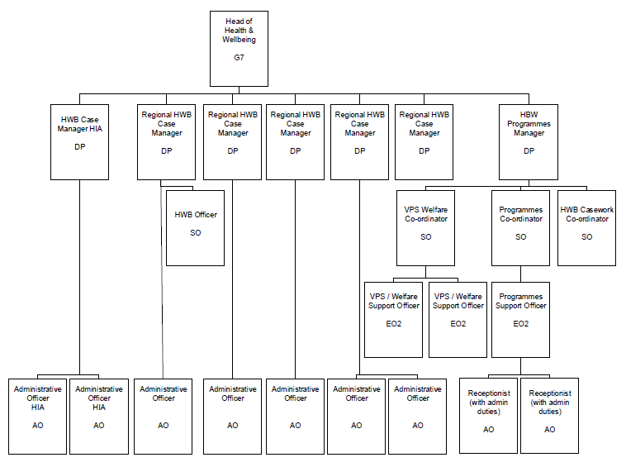

Responsibilities

The key elements that constitute the role of the Victims Payment Scheme/Welfare Support Officer for the Victims and Survivors Service are as follows:

Information Management

- Develop an understanding of the Troubles Permanent Disablement Payment Scheme and its underpinning legislation.

- Gain a thorough understanding of VSS file management systems, ensuring that key information is identified/collated and shared promptly when required

- Locating, identifying and collating all relevant information held by VSS for release to the applicant and/or the Scheme Administrator.

- Initial identification of individuals and/or groups within VSS’ existing client base for whom payments under the Troubles Permanent Disablement Payment Scheme and/or other Welfare initiatives may be applicable.

- Ensuring adherence to the provisions of GDPR in relation to the management of sensitive client information.

- Maintain detailed records of all interactions and correspondence. Update management information systems on a regular basis

Support Delivery of Welfare Advice Services

- Support the VPS/Welfare Co-ordinator to develop and coordinate support systems and processes to be utilised by Welfare Advisors employed in community and voluntary sector organisations.

- Develop and maintain a knowledge of the existing welfare system relating to victims and survivors and their families, to ensure pathways are seamless and responsive.

- Support VPS/Welfare Co-ordinator to identify / deliver upon the training and support needs of VSS staff and funded organisations and assist with building capacity to ensure quality services for victims and survivors.

- Assist the VPS/Welfare Co-ordinator in providing effective, evidence-based advice and information to VSS Senior Management.

Communication with Troubles Permanent Disablement Payment Scheme Administrator (The Victims Payment Board)

- Establish, maintain and promote partnership working and professional relationships with key stakeholders including the VPS Administrator and other relevant bodies.

- Act as a point of contact to address any queries/concerns arising from client applications under the VPS, in cases where VSS are providing direct support to applicants.

- Interact with appropriate agencies in the preparation and presentation of applications and appeals.

- Provide effective, evidence-based advice and information to the VPS Administrator as required in a secure manner.

Business Improvement and Quality Management

- Support VPS/Welfare Co-ordinator to collate and coordinate relevant information from VSS funded organisations and individual cases into programme level outcome reports that can inform learning and improvement of VSS services/support.

- Use initiative to identify and implement improvements to the operational systems and processes in support of the business.

- Assist in the maintenance of all policies and procedures to be followed in relation to the Troubles Permanent Disablement Payment Scheme.

- Promote good health and safety practices in the day-to-day work of the VSS and take necessary action to ensure a healthy and safe working environment.

- Monitor case work against plans and budgets and ensure targets are met and to identify and flag up variances.

- Input into the development of key Business Plan targets for the Team and monitor the progress against Key Performance Indicators flagging up any risks or concerns.

- Support the VPS/Welfare Co-ordinator to identify the training and support needs of VSS funded organisations and assist with building capacity to ensure quality services for victims and survivors.

- Provide evidence for input into formal reports to management; detail outcomes achieved through development work with organisations that deliver services to victims and survivors.

Corporate Governance and Compliance

- Support in the preparation of guidance notes and provision of advice to organisations managing Troubles Permanent Disablement Payment Scheme applications.

- Continue to improve and update associated policies and procedures.

- Ensure adequate and appropriate record keeping. Update management information systems on a regular basis.

Personal Development, Performance and Professionalism
- Endeavour to maintain high standards of personal accountability and ongoing confidence of VSS stakeholders.

- Facilitate liaison with stakeholder organisations. Develop interpersonal skills and self-motivation.

- Undertake additional duties, appropriate to the grade as requested.

The foregoing is a broad range of duties and is not intended to be a complete description of all tasks. It is important to note that the responsibilities may change to meet the evolving needs of the Victims and Survivors Service.

