Hosting Proforma
Department of Finance, Construction and Procurement Directorate

Name of Host
Organisation

1. Interchange Manager’s details
William Black
Name

Organisation/
Properties Division, Building Standards Branch

Department
6th floor Goodwood House
44 May Street
Belfast
BT1 4NN

Address

Telephone
028902 57038

Number
billy.black@finance-ni.gov.uk

E-mail

Type of Opportunity
Secondment – 2 Lead Writers for Building Regulations - Part E (Fire Safety)
(Professional and Technical opportunity)

2. Details of hosting opportunity

Description of opportunity

There are two exciting and challenging opportunities to work on the development and maintenance of the Building Regulations (Northern Ireland) 2012 (as amended) in the area of Fire safety (Part E) and associated guidance in Technical Booklet E – Fire safety (TBE). The opportunities are in Properties Division, Building Standards Branch (BSB), in the Department of Finance’s Construction and Procurement Directorate. BSB comprises three units, Building Regulations Units 1 and 2 and a Legislation Unit. The opportunities are in the Fire Safety Section in Building Regulations Unit 1.
The post holder will, in the first instance, be based in Goodwood House, May Street, Belfast, BT1 4NN, however, the NICS operates a hybrid working policy which allows staff to work between the office and remote working locations.
The postholder will bring forward fire safety amendments to the building regulations and associated technical guidance to address an existing backlog, and update fire safety standards in line with other jurisdictions. In addition, new requirements are expected from other jurisdictions in the coming 2 years, that will need to be considered and addressed in the local context.
This will require the postholder to work on their own initiative to bring forward a package of amendments on selected areas of a fire safety work programme. As part of the Branch’s fire safety team you will also contribute to the scrutiny of other packages of amendments for all other areas of fire safety proposed for amendment:
Fire Safety work programme 2022-2025

- A Phase 1 package of amendments relating to external fire spread requirements on external walls and certain attachments was introduced here and came into effect on 1 April 2022. This ‘Ban on Combustible Materials’, was similar to the ban previously introduced in England and Wales. Since its introduction, further changes have been made in England and in Scotland which will need to be considered in the local context.

- A Phase 2 package of priority fire safety amendments is ongoing, to update fire safety provisions for sprinklers in certain buildings, smoke ventilation in blocks of flats, fire safety information requirements and issues that affect firefighters for facilities and access for the Fire and Rescue Service. The package includes consideration of some of the recommendations from the Phase 1 report of the Grenfell Tower Inquiry. Among other things this includes provision in blocks of flats for Evacuation alert systems, wayfinding signage and secure information boxes.

- A subsequent Phase 3 package of amendments will result in a new consolidated TBE (Fire safety) and bring NI further up to date (i.e. closer alignment with the equivalent fire safety provisions in England’s ADB1 and ADB2). The changes required to TBE are extensive and will effect means of escape provisions in dwelling houses, flats and other non-dwelling buildings; and, amend internal fire spread – Linings requirements; internal fire spread – Structure requirements; External fire spread requirements and Facilities and Access requirements for the Fire and Rescue Service.

- Further amendments are expected in other jurisdictions in the coming period, alongside publication of the Phase 2 report from the Grenfell Tower Inquiry, due in 2023. Consideration of these amendments and the recommendations of Phase 2 of the Grenfell Inquiry may also prompt a need for further packages of amendments.

There will be opportunities to engage with officials across the NICS, local councils, members of the statutory Northern Ireland Building Regulations Advisory Committee (NIBRAC) and its technical sub-committees, officials in other jurisdictions, BSI committees and industry stakeholders.
The opportunity may involve occasional travel to attend meetings, workshops and seminars.

Main objectives of the opportunity

To develop robust policy and legislative requirements for fire safety standards in the local Building Regulations in pursuit of the objective and function of Building Regulations which is ‘to set requirements and standards for building that can reasonably be attained, having regard for the health, safety, welfare and convenience of people in or around buildings and others affected by buildings or building matters. They also further the conservation of fuel and power, and make provisions for access to buildings’. This opportunity will not only seek to address an existing backlog but will include new proposals implemented in other jurisdictions in the local context.

To realise the objective the main job activities and responsibilities will include:
•Leading in writing amendments to Part E (Fire Safety) of the Building Regulations, associated Technical Booklet E (Fire safety) and other supporting documentation.
•Contributing to the development and analysis of proposed amendments to other aspects of the Building Regulations affected by fire safety matters, for example Part A (Interpretation and General) and Part B (Materials and Workmanship).
•Undertaking necessary research and investigative work to develop initial policy proposals on fire safety, developing and providing draft information papers.
•Preparation of the Department’s proposals for consideration by the Northern Ireland Building Regulations Advisory Committee (NIBRAC) and its Technical sub-committees, the Departmental Finance Committee and for public targeted consultation (e.g. with the construction industry).
•Provision of draft information papers for Ministerial, Finance Committee and NIBRAC briefings.
•Development of final policy proposals, following consultation with NIBRAC, the public, and the Departmental Finance Committee, for approval by the Minister.
•To carry out any necessary impact assessments, for example Regulatory Impact Assessments (RIA) in liaison with Departmental Economist on proposed amendments, and the development of public consultation documents/processes.
•Providing input/comment on proposed legislation, policy, research papers and draft publications prepared by other Government Departments, research bodies and Institutes and in relation to the effect of such proposals on the Building Regulations and other relevant policy and legislation here.
•Work closely with Branch colleagues, NIBRAC members and other external government and industry stakeholders to build effective networks and positive working relationships in support of business objectives on Building Regulations and any associated Ministerial and Executive agreed outcomes.
•Present the work and position of the Department at interdepartmental meetings and local groups (e.g. BSI committees, NI Fire safety Liaison Panel meetings) and nationally at Government Department and research body meetings in England, Wales, Scotland and the Republic of Ireland. Liaise with the above jurisdictions on building regulations fire safety matters.
•Provide sufficiently detailed and sound evidence-based recommendations to management in a timely manner, taking account of the wider context of building regulations in other jurisdictions.
•Giving accurate and timely responses to queries from district council building control representatives, the construction industry and the public.
•Inform and support the work of other staff across the Branch on other aspects of the Building Regulations that may affect Fire Safety.
•Support management and staff in the Branch legislative team in the development of new legislation for Part E Fire safety.
•Contribute to the Branch's input to the Expert Panel that is considering arrangements for local implementation of the Hackitt recommendations (Post Grenfell fire).
•Preparing timely responses to statutory appeals casework.
•Provision of background information and draft responses to correspondence including Ministerial cases and Assembly Questions on Building Regulations related matters.
•Delivering presentations on the background to amendments of the Building Regulations and related technical matters at public seminars and conferences.
•Liaison with district council building control on disseminating information on fire safety amendments to inform training seminars and FAQs.
•Writing occasional articles for publication including in technical circulars.
•Managing assigned work and providing appropriate reports to Senior Management, clients and others.
•Within the appropriate areas of fire safety, contribute to the secretariat support for NIBRAC Part E subcommittee meetings.
•Identify risks promptly and provide possible solutions to Branch management.
•Operate Branch processes and systems to ensure effective governance of risk, performance, information (including FOI and EIR requests) management and data protection matters by adhering to approved policies and procedures.

3. Skills requirements

What qualities, skills and experience is required from the individual

Applicants will have qualifications relevant to and knowledge skills and experience gained in working in the built environment and in the application and enforcement of Building Regulations.

Qualifications

They must hold, by the closing date for applications:

- A BTEC/Ordinary National Certificate in a Building Construction related discipline with a minimum of 5 years post qualification experience, gained within the last 7 years in the application of or development of the Building Regulations and relevant supporting standards;

OR

- A BTEC/Higher National Certificate or Higher National Diploma in a Building Construction related discipline with a minimum of 4 years post qualification experience, gained within the last 7 years in the application of or development of the Building Regulations and relevant supporting standards;
OR
- A Degree in a Building Construction related discipline with a minimum of 3 years post qualification experience, gained within the last 7 years in the application of or development of the Building Regulations and relevant supporting standards.
OR
- Membership of a Chartered Professional Body incorporated under or with Royal Charter; holding the title of Registered Architect, Chartered Engineer, Chartered Surveyor or a title of equal standing from another construction profession; with a minimum of 2 years post qualification experience, gained within the last 7 years in the application of or development of the Building Regulations and relevant supporting standards.

Knowledge and skills and Experience

Applicants will be able to demonstrate that they have:

•Good analytical skills – the ability to understand and analyse information relevant to Building Regulations and the built environment.
•Detailed knowledge of the requirements of the local Building Regulations and experience in their enforcement.
•The ability to read and understand construction drawings and plans and technical documents and assess these against the substantive requirements of the Building Regulations Part E (Fire safety).
•An ability to read and understand building regulations legal issues, seeking legal advice if necessary, and explain these accurately to technical (construction disciplines) and non-technical audiences.
•Experience of handling building regulations queries from both technical and non-technical sources.
•The ability to lead, manage, plan and organise the flow of work through their work area and prioritise work to meet set deadlines.
•Good oral and written communication skills in order to liaise with a range of stakeholders within the Department, NIBRAC, local councils, other departments, counterparts in other jurisdictions and industry stakeholders and demonstrate ability to represent the Branch at meetings, workshops, conferences and working groups.
•Experience in drafting correspondence for Senior Management (considered to be Director level or above).
•An ability to work in a team and on their own initiative.

4. Personnel: Please state below

Who will the individual report to?
Damian Fairley, acting head of Building Regulations Unit 1

Who will be the individual’s line manager and/or reporting officer?
Damian Fairley, acting Head of Building Regulations Unit 1

5. Transfer of learning
Please give details of how the Opportunity will benefit your organisation, the
individual and their organisation.

This is a collaborative arrangement for the sharing of knowledge, ideas and experience between central government employees who develop and maintain the building regulations and associated technical guidance and local government counterparts, who enforce the building regulations. It will be of benefit to the parties involved - Building Standards Branch (the host), the individual employees and the parent employer (Local Councils). It is a staff development opportunity for the individual employees involved through acquired learning.

The opportunity will benefit the Department as it will provide an opportunity for BSB staff to work with individuals with expertise in an external enforcement environment and a different perspective on Fire Safety matters gained from this experience. BSB will gain a greater understanding of the enforcement work of Local Council Building Control and inform the development of better regulation and guidance.

The successful candidates and their organisations will benefit from a better understanding and experience of the central government policy and legislative environment and working with central government and its stakeholders throughout the process of developing and amending Building Regulations and associated technical guidance. They will have a unique opportunity to influence the future direction of fire safety standards. The knowledge, skills and experience they gain will be of value to their own organisation and through it enhance Building Control NI’s (and its Fire Safety Panel) liaison work with the Department.

6. Logistics
Please provide details of the likely start date, duration, location, form of transport required, resources (i.e.; desk, PC, etc.) and funding arrangements for the opportunity.

Start Date: As soon as possible

Duration: 2 years (extensions may be possible)

Location: Hybrid working in Building Standards Branch, Goodwood House, 52 May St, Belfast BT1 4RA and remotely.

Resources: Standard IT equipment (laptop etc.) will be provided to facilitate hybrid working along with standard office resources.

Funding: The Department will cover salary costs and appropriate travel and subsistence costs incurred in undertaking the duties of the post. Secondees will remain on their current salary with their employer continuing to pay salary, recouping from the Department at agreed periods.

Further information: Building Regulations in Northern Ireland | Department of Finance (finance-ni.gov.uk)

Closing Date: Applications* must be submitted by 4.00pm on Monday 12 December 2022 to: interchangesecretariat@finance-ni.gov.uk

*These opportunities are not open to NI Civil Service staff.

7. Endorsement

Interchange Manager

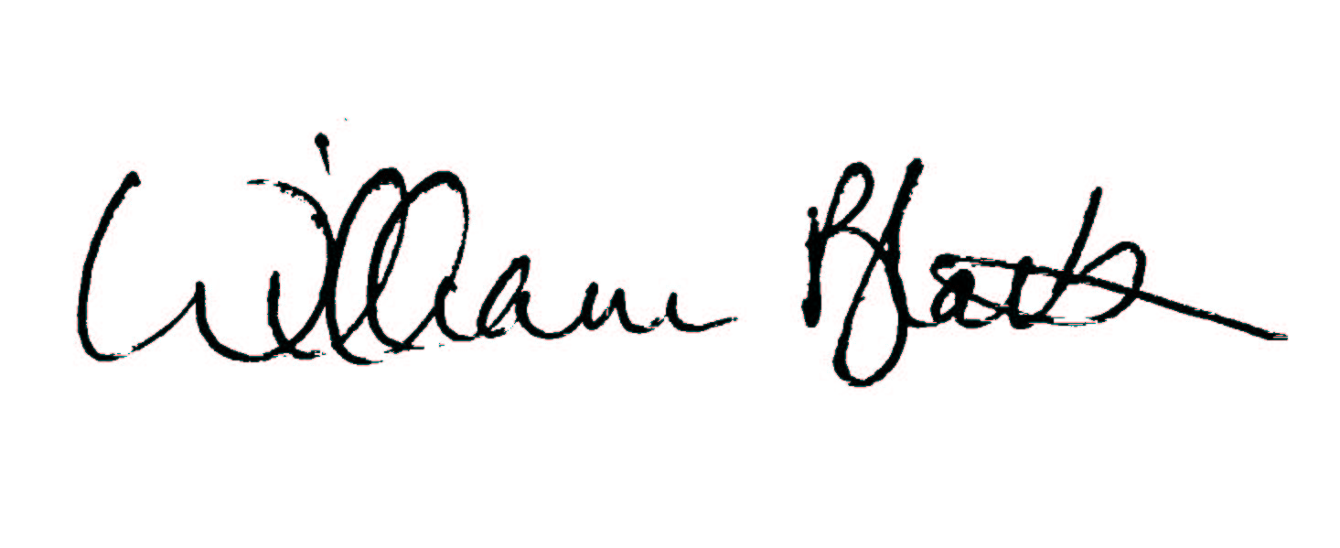
Signed:

21 September 2022
Date:

